How to view details of interviews taking place within the next 5 days

The Interviewer can check what Interviews are taking place in the next 5 days.
The interviewer can log into eRecruitment by doing the following.

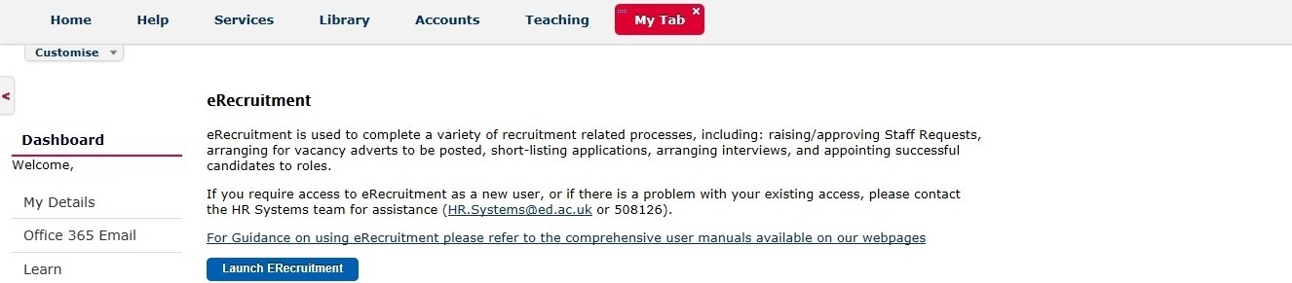

Click on the Launch eRecruitment button.

The first screen the interviewer will see is:
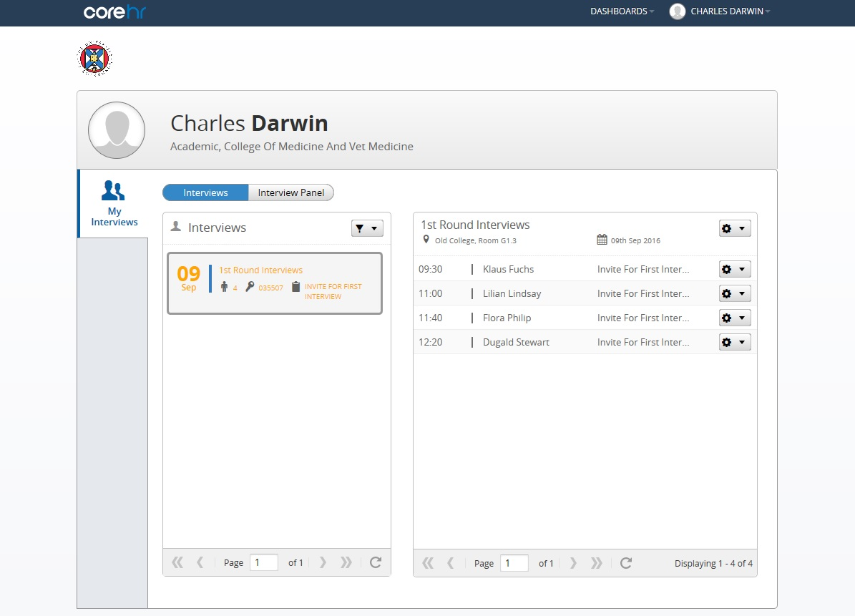

If the interviewer has an upcoming interview within the next 5 days, and the recruiter has created an interview schedule and assigned the interviewer to the interview schedule, then this will appear for the interviewer as soon as they log in.

If the interviewer is not able to see a vacancy as soon as they log into the screen, this could be for any of the following reasons:

- The recruiter has not added the interviewer to the interview panel.

- The recruiter has added the interviewer to the interview panel, but not created an interview schedule and assigned both the interviewers and applicants to the interview schedule.

- The recruiter has added the interviewer to the interview panel, AND has created the interview schedule and assigned both the interviewers and applicants to the interview schedule, but the date of the interview on the schedule is not within 5 days of the date the interviewer has logged into Core Portal.

On the Interviews screen, the interviewer can glean the following detail:

Date of Interviews

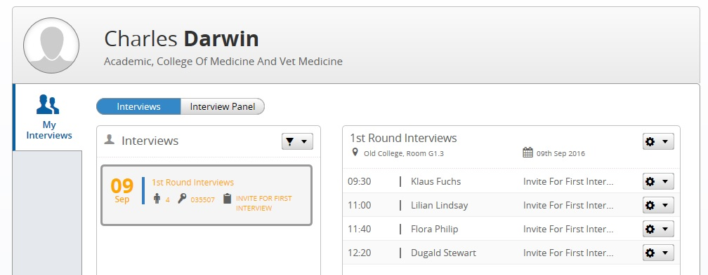

Vacancy Number Location of Interviews Applicant Names and corresponding interview time

For scenario c) the interviewer can check if they are assigned to the interview schedule by selecting All in the filter.
This will list all the Interview Schedules the Interviewer has been assigned to regardless of date.
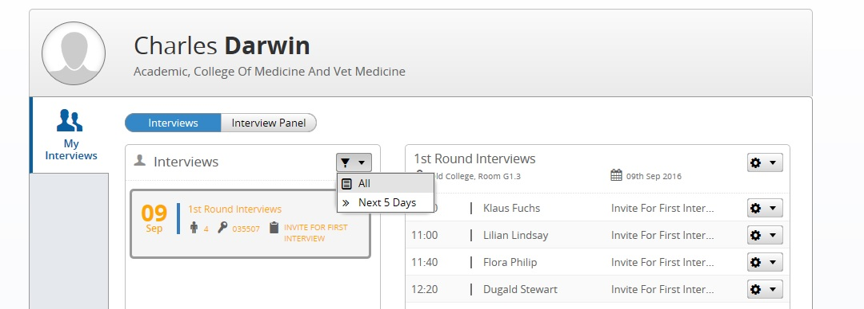

For scenario b) the interviewer can view applications, but unable to view details of the actual interview until the schedule has been created and assigned to interviewers and applicants.
To view applications the interviewer can click on Interview Panel button

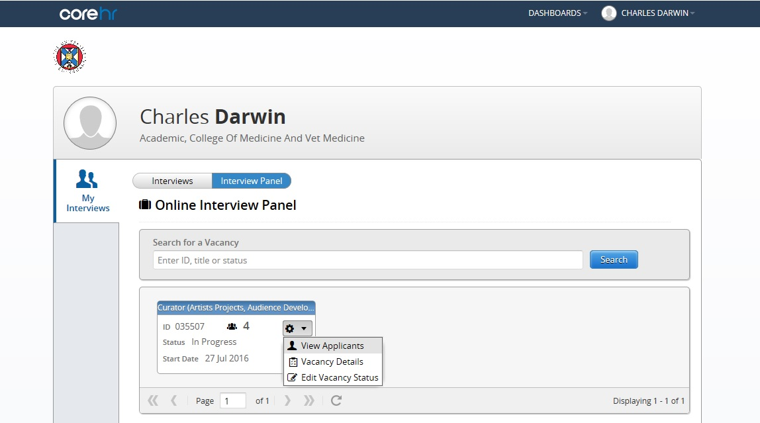

Then click on the cog wheel icon, then click on View Applicants.

After clicking View Applicants, the following screen will appear listing the applicants and their applicant status.
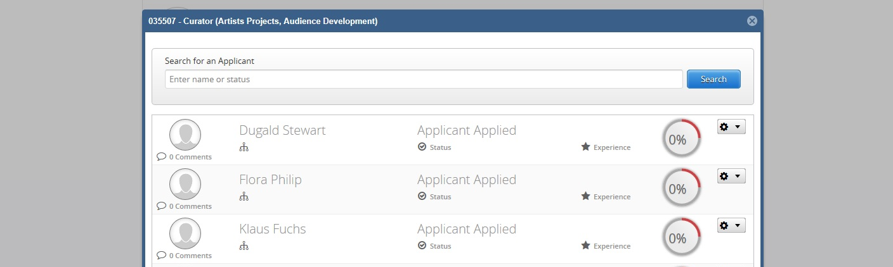

To view individual applications, click on the cog wheel icon.

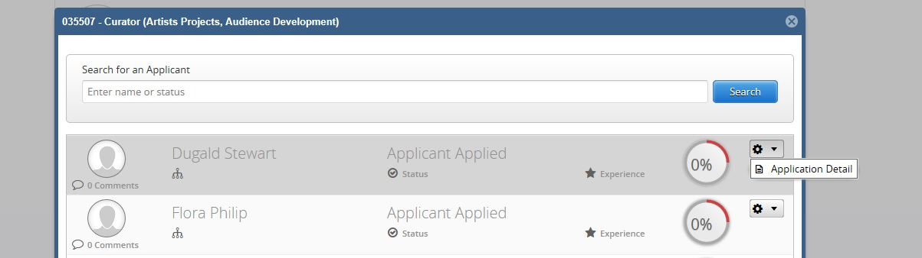

Then click on Application Detail.

This will open the application in a web browser window.
