How to complete fields within Advertising Details section

If your vacancy is not to be advertised at all, you do not need to do anything within the Advertising Details section.

Internal Vacancies - Advertising Details

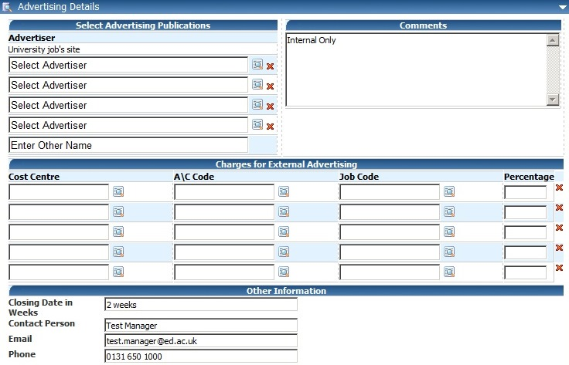

If the vacancy is for Internal applicants, type Internal Only in the comments box

The University’s Jobs site
www.vacancies.ed.ac.uk is chosen automatically by default.

Complete the Other Information section
This information will feed directly to the Vacancy and will show on the University’s Jobs site.

Enter the number of weeks that you require the vacancy to be advertised
(e.g. 2, 3 or 4 weeks).

Enter the full name of the contact person for the vacancy, their email address and their full phone number
(not just extension number).

NB: Details of the Contact Person may be passed to applicants.

External Vacancies - Advertising Details

If the vacancy is for External and Internal applicants

The University’s Jobs site www.vacancies.ed.ac.uk is chosen automatically by default.

A vacancy can be advertised by an external source.
Choose from a list by clicking on the icon. You can choose more than one external source.

If you cannot find the external source on
the list, then type the name in this field

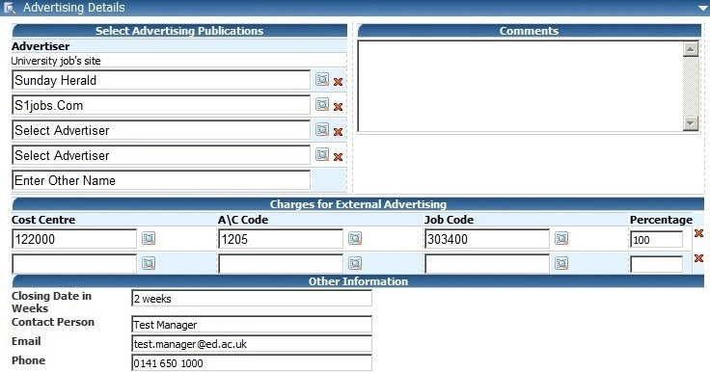
To remove an advertiser, click on the
icon

Advertising Details - Charges for External Advertising

Click on the icon to search for the correct Cost Centre, A\C Code and Job Code details.

The system will ensure that figures within the Percentage column add up to 100 in order to save and submit the Staff Request.

To remove a line of charge detail, click on the red X to the right of the row you wish to remove.

Complete the Other Information section
This information will feed directly to the Vacancy and will show on the University’s Jobs site.

Enter the number of weeks that you require the vacancy to be advertised (e.g. 2, 3 or 4 weeks).

Enter the full name of the contact person for the vacancy, their email address and their full phone number (not just extension number).

NB: Details of the Contact Person may be passed to applicants.

