How to access a Staff Request once it has been saved or submitted

Log in to MyEd www.myed.ed.ac.uk and open the eRecruitment channel.

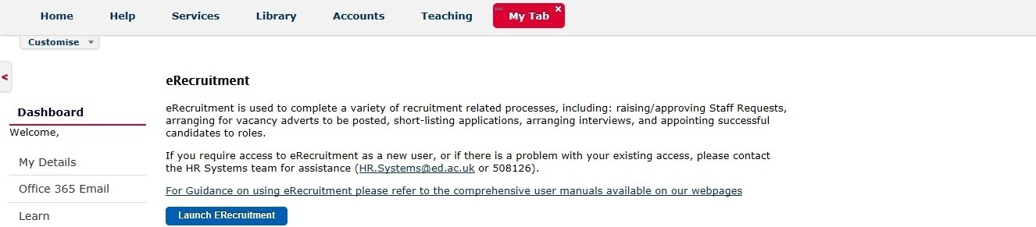

Click on the Launch eRecruitment button.

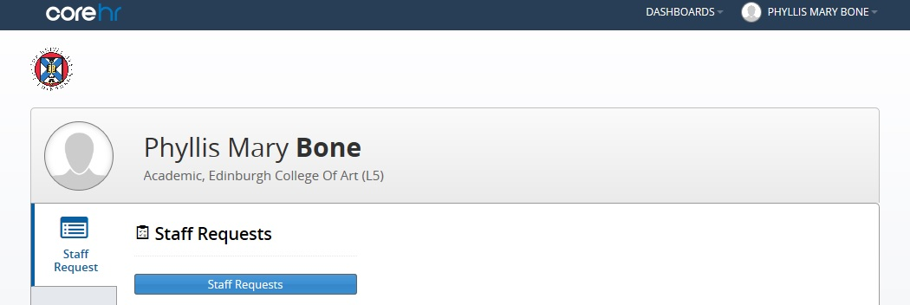

Click on the Staff Requests button.

The default screen will be My Requests: Planned
If you have any staff requests that have been started and not yet submitted, then they will show in this screen
If for any reason these do not display automatically, click on Planned
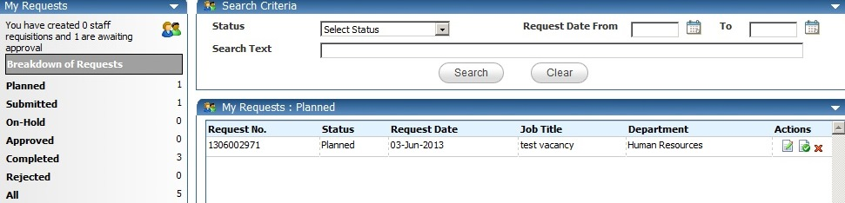
To delete a Staff Request which is partially completed or yet to be submitted, then click the icon.
To view / edit your staff request, click the icon.
The Staff Request will then open and you will be able to view/ edit as required.

Click OK and then OK again.

