How to complete fields within Assign Cost Allocations section

Within the Assign Cost Allocations box, enter the appropriate details relating to where the successful candidate’s salary will be charged to. You must complete each of the fields in this section.

NB: You do not need to enter anything in the Comments box within the Assign Cost Allocations section.

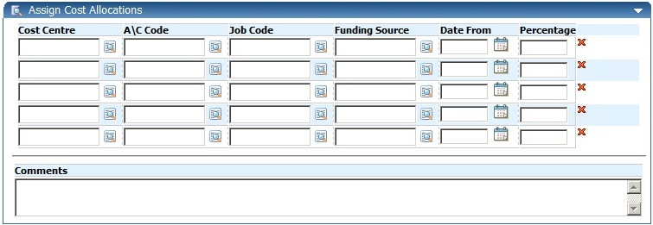

Account Code guidance can be accessed via the Financial Policies and Guidance wiki:
https://www.wiki.ed.ac.uk/display/Finance/Financial+Policies+and+Guidance

A direct link to “CODING STAFF COSTS – ACCOUNT CODES” guidance is:
https://www.wiki.ed.ac.uk/pages/viewpage.action?title=Financial+Policies+and+Guidance&spaceKey=Finance&preview=/55315483/286329101/Staff%20Costs%20account%20guidance%20160915.pdf

To select a cost centre (as with the Cost Centre field in the first part of the Staff Request) click on the magnifying glass icon and then type the cost centre (or letters/numbers contained in the cost centre) in the Search box. You will need to enter at least 2 numbers/letters in order for appropriate items to display. Next, click on the small magnifying glass to the right of the Search box and a list of cost centres containing the numbers/letters you entered will display. Select the correct cost centre.

You will need to do the same to complete the A\C Code, Job Code (once you have clicked on the magnifying glass icon you will need to wait for the box to display Select Job Code (at the top) before typing anything in the Search box), and Funding Source fields.

Funding Source is the funding source/body that the employee’s salary will be charged to.
The following rules should be applied when completing this field:
- Job Code = Snnnnn (i.e. S00001) then always use funding code UNIVERSITY OF EDINBURGH
- Job Code = Bnnnnn (i.e. B00001) then always use funding code DEPARTMENTAL INCOME
- Job Code = Gnnnnn (i.e G00001) then always use funding code DEPARTMENTAL FUNDS
- Job Code = Dnnnnn then always use funding code DEPARTMENTAL DONATIONS
- Job Code = Ennnnn then always use funding code ENDOWMENT
- For all other Job Codes (beginning R etc) please select the funding source/body from the pick list.

In the Date From field, enter today’s date (the date on which you are raising the Staff Request). Again, dates should be entered in the format DD/MM/YY. Alternatively, you can click on the calendar icon and then select the correct date.

It is possible to split the salary cost allocations but you will need to ensure that figures entered in the Percentage column add up to 100.

