How to verify if a Staff Request has been converted to a Vacancy

After a Staff Request has been approved by both the 1st and 2nd level approvers, the Originator will receive a system generated email to advise the staff request has been approved.

The HR Systems will then create the Vacancy Reference number. After the Vacancy Reference number has been created, a system generated email is sent to Local HR, advising the Vacancy has been created. The Local HR team will scrutinise the request and then advise the Originator of the Vacancy Reference number.
This may take 2-3 working days.

The Originator can also view the progress to see if the Staff Request has been converted to a vacancy.

Log in to MyEd www.myed.ed.ac.uk and open the eRecruitment channel.

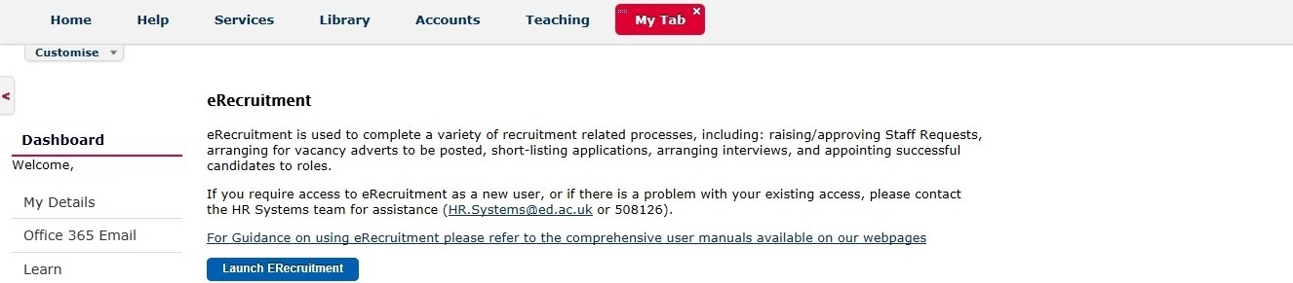

Click on the Launch eRecruitment button.

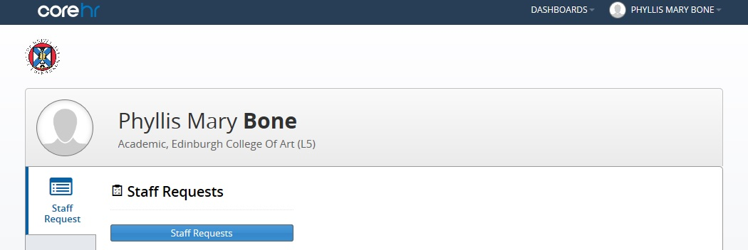

Click on the Staff Requests button.

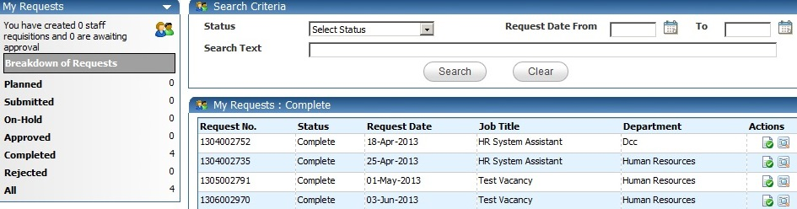

Click on Completed Then click on the icon.

The Staff Request will open.

Scroll to the bottom of the Staff Request and you can view the Approval History.

If the Approval History is showing Complete, it means the staff request has been approved and the Vacancy ID has been created.

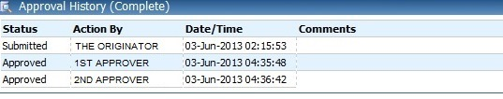

If your Staff Request is sitting in the My Requests: Approved, this would indicate the Staff Request has been approved, but the Vacancy ID has not been created.

