How to copy a Staff Request

A Staff Request can be copied from an existing Staff Request by the same Originator.

It’s not possible to copy a staff request from a fellow Originator.

Additionally, if an Approver has rejected a Staff Request, and has provided feedback on amendments that need to be made, the Originator can copy the rejected Staff Request and submit the amended copy

Log in to MyEd www.myed.ed.ac.uk and open the eRecruitment channel.

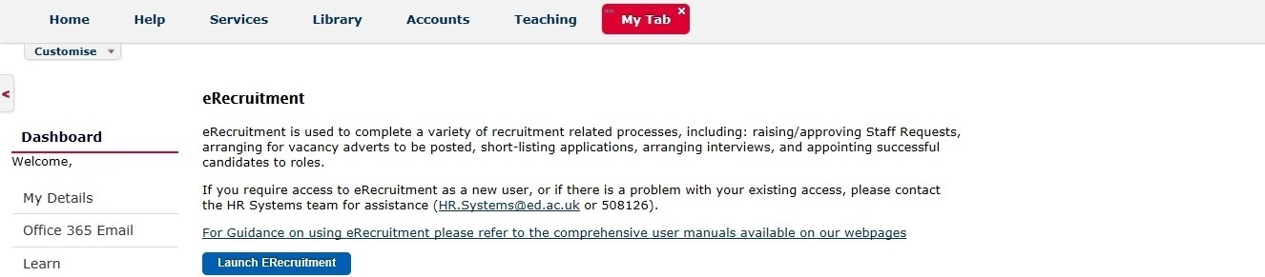

Click on the Launch eRecruitment button.

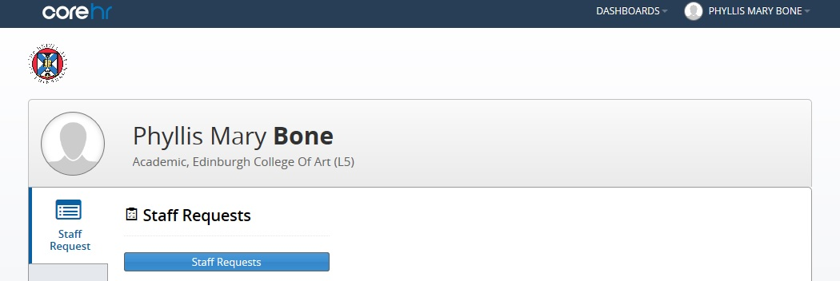

Click on the Staff Requests button.

In this instance, we are looking at a rejected staff request in the My Requests: Rejected section

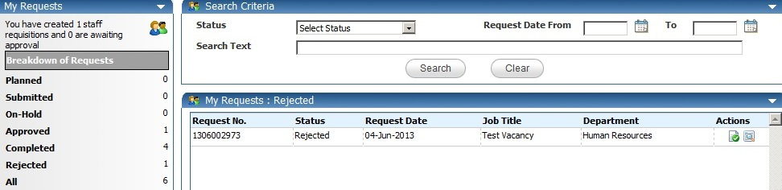

Copy the staff request by clicking on the icon.
A confirmation message will appear.

Click OK.
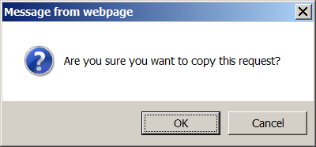

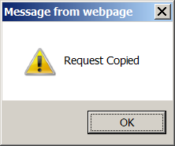
The action is complete.

Click OK.

Wait for 10 – 15 seconds until the new staff request which has all the same details as the rejected staff request is generated and loaded on your screen.

The new staff request will show as Amend Request and have a new staff request number.

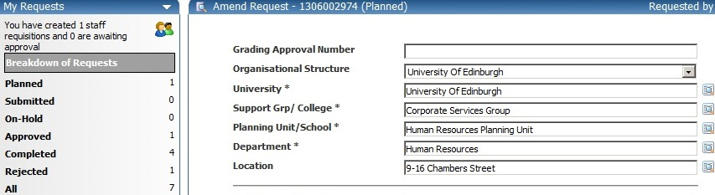

The new staff request will be held in your My Requests: Planned section.
NB: Please scroll to bottom of screen and save your changes.

