How to create a new Staff Request

Log in to MyEd www.myed.ed.ac.uk and open the eRecruitment channel.

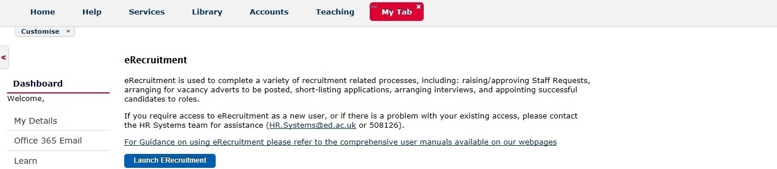

Click on the Launch eRecruitment button.

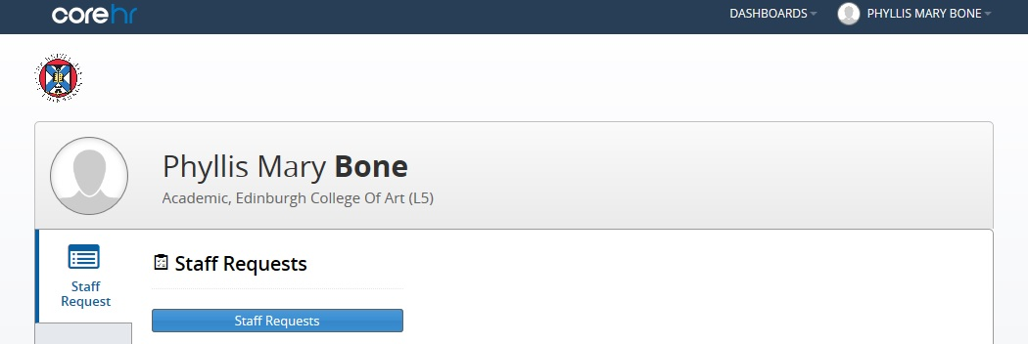

Click on the Staff Requests button.

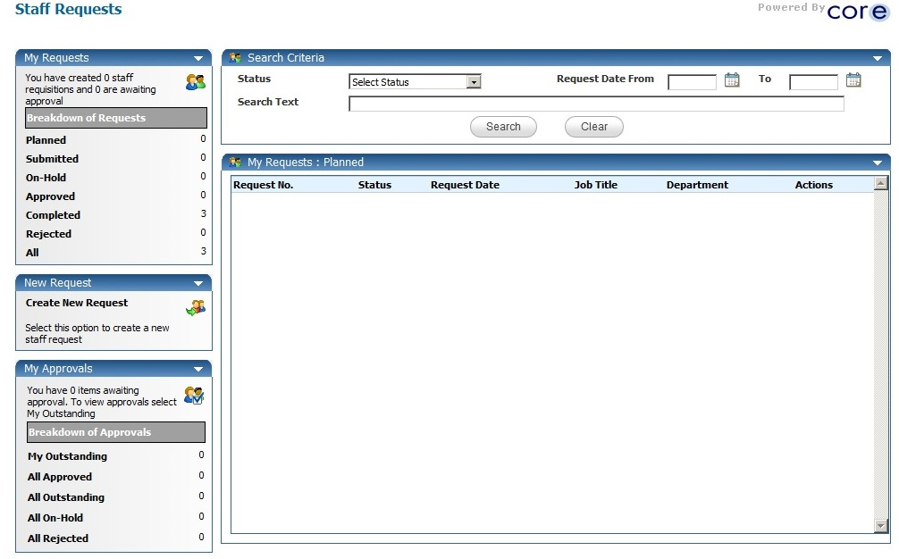
An additional window will open.

Click on Create New Request

A new Staff Request will open.

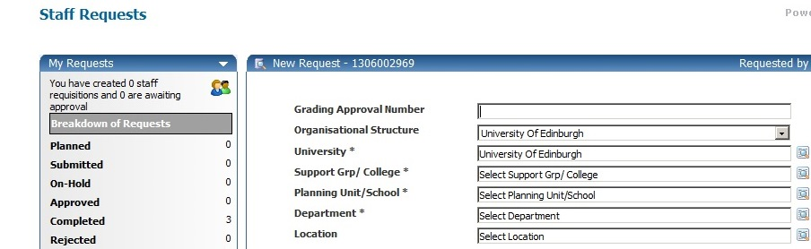

The system issues a unique Staff Request (New Request) number for each Staff Request raised.

NB: It may be useful to take a note of this to identify your Staff Request at a later stage.

Complete each field of the Staff Request as appropriate. Please note that all fields marked with a [*] are mandatory and must be completed in order to save and submit the Request for approval.

Please note that some of the details entered on the Staff Request will feed through to the vacancy advert.

Some of the fields within the Staff Request require you to select an item from a pick-list.
To do this, click on the magnifying glass icon.

Type the name (or part of the name) of the option you are looking for into the Search box
Then click on the magnifying glass

Alternatively, you can choose from a list if this is populated.

