How to search for a specific Staff Request

You can use the Search Criteria box at the top of the screen to find a particular Staff Request or category of Staff Requests if you know which status they fall under.

Log in to MyEd www.myed.ed.ac.uk and open the eRecruitment channel.

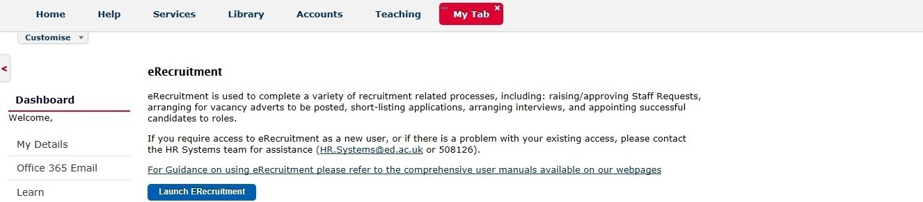

Click on the Launch eRecruitment button.

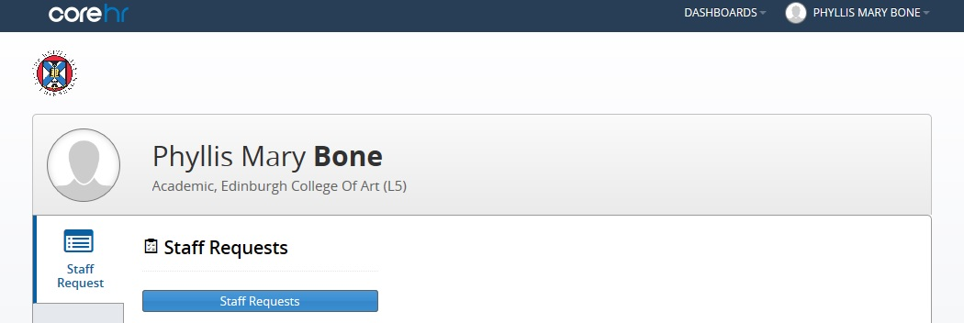

Click on the Staff Requests button.

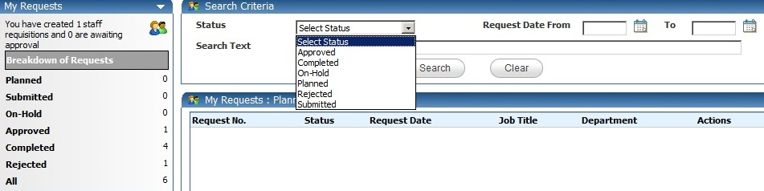
Select a status from the drop down list

You must always select a status in order to use the Search Criteria facility.

After the status is selected, you can search by keyword. If you know the Staff Request number, type this in the Search Text box.
As well as using keyword search, you can search by using a date range.
Type the date in dd/mm/yy format, or click the icon to pick from the calendar.

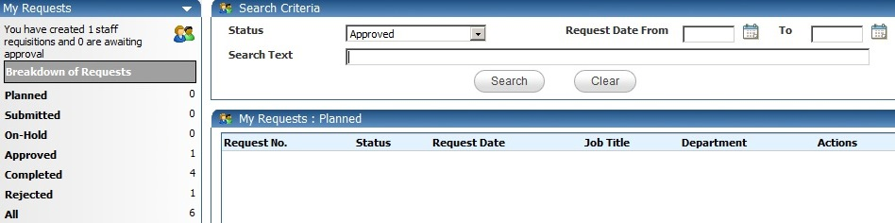

Once you have entered your search criteria, click Search.

Alternatively, click on All.

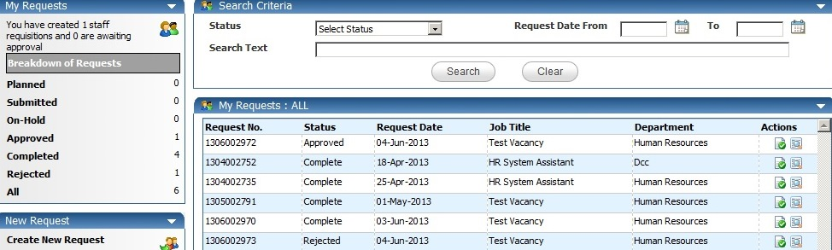

This will list all of your Staff Requests regardless of their status.
You can scroll up and down to find your vacancy and the click the icon to view the request.

