eRecruitment

Originator User Manual
How to access the eRecruitment system 2
How to create a new Staff Request 4
How to complete fields within New Request screen 6
How to complete fields within Assign Cost Allocations section 9
How to attach a document to a Staff Request 10
How to complete fields within Advertising Details section 11
How to submit a completed Staff Request 13
How to access a Staff Request once it has been saved or submitted 14
How to view a submitted but not yet approved Staff Request 15
How to verify if a Staff Request has been converted to a Vacancy 17
How to view when and why a Staff Request has been rejected 19
How to search for a specific Staff Request 21
How to print a Staff Request 23
How to copy a Staff Request 25
How to exit eRecruitment 27

How to access the eRecruitment system
Log in to MyEd www.myed.ed.ac.uk and open the eRecruitment channel.

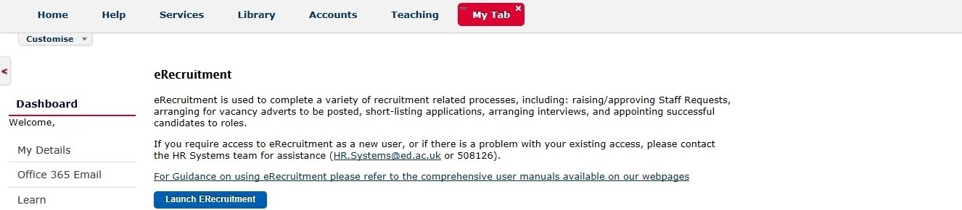

Click on the Launch eRecruitment button.

If you are unable to locate eRecruitment in MyEd, you can add the eRecruitment channel.

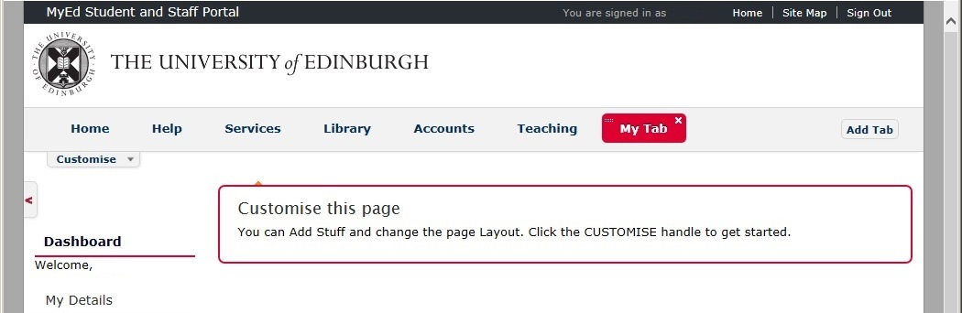

- Click on a Tab
- “My Tab” has been clicked on.
(NB: To indicate it has been clicked on,
the tab background colour is red.)
- Click on Customise

A drop down panel will open, which will allow you to “Add Stuff”

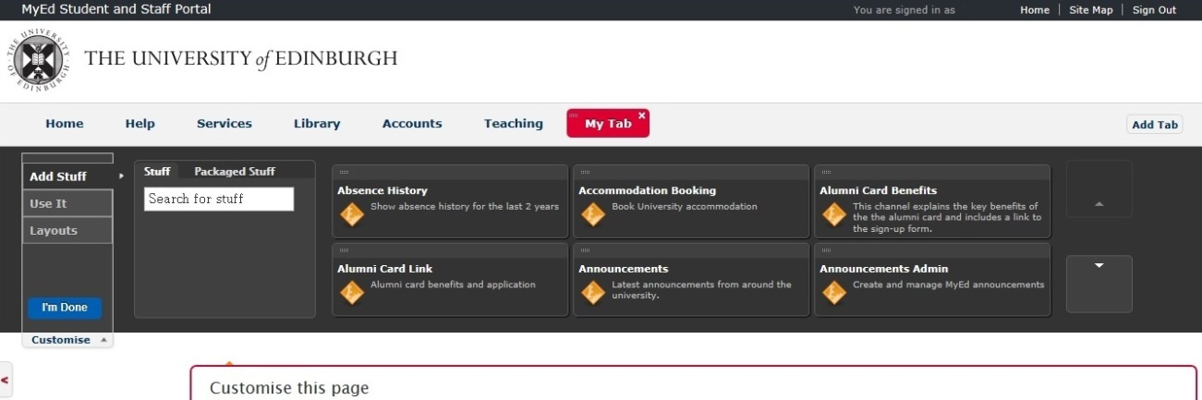
Click the Scroll down arrow until you find the “eRecruitment” channel.

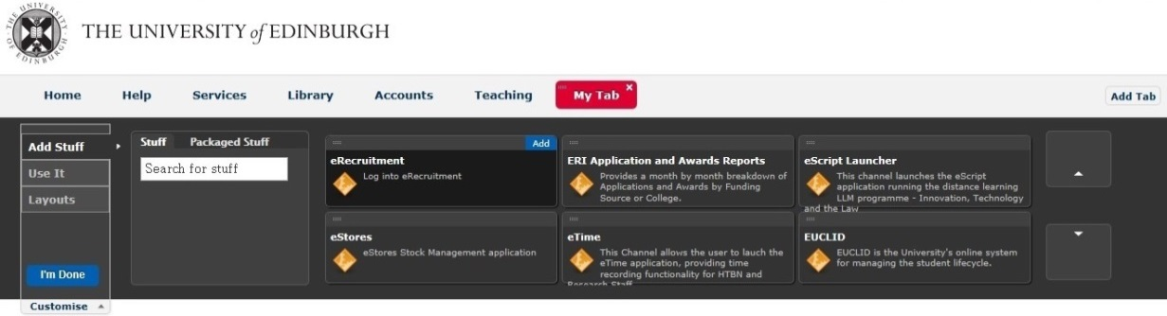
Hover your mouse over the “eRecruitment” channel and then click on Add

This will add the “eRecruitment” channel into your “My Tab” space.

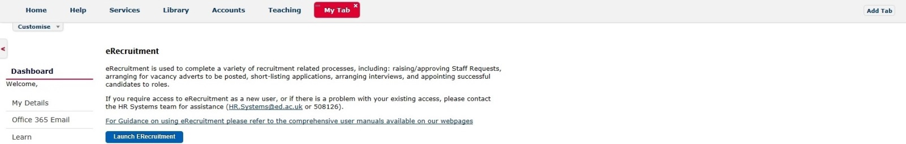

This is available in video tutorial, called “Customising your layout” and can be viewed at:
http://www.ed.ac.uk/schools-departments/information-services/computing/comms-and-collab/myed-portal/using-myed

When you click on the Launch ERecruitment button in MyEd, you will be directed to this screen:

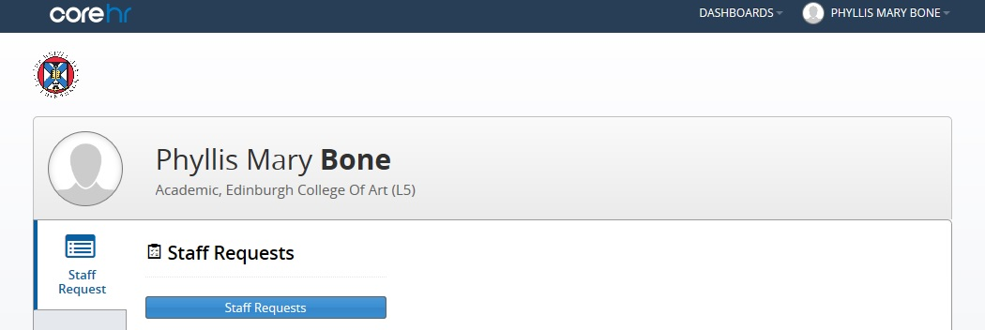

Click on the Staff Requests button.

How to create a new Staff Request
Log in to MyEd www.myed.ed.ac.uk and open the eRecruitment channel.

Click on the Launch eRecruitment button.

Click on the Staff Requests button.

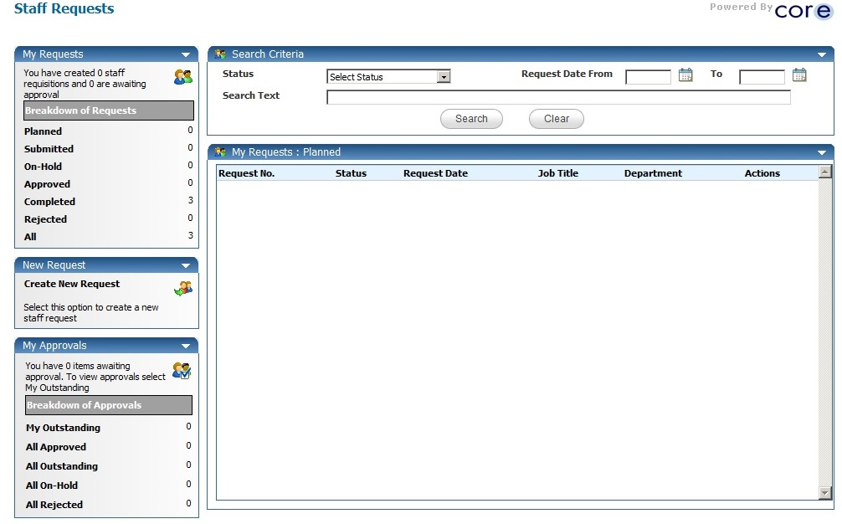
An additional window will open.

Click on Create New Request

A new Staff Request will open.

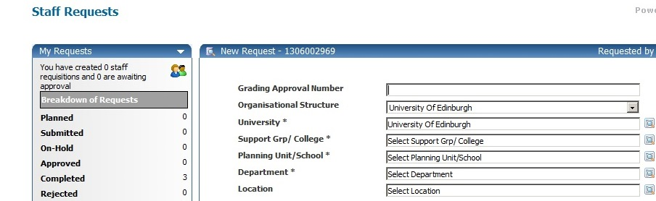

The system issues a unique Staff Request (New Request) number for each Staff Request raised.

NB: It may be useful to take a note of this to identify your Staff Request at a later stage.

Complete each field of the Staff Request as appropriate. Please note that all fields marked with a [*] are mandatory and must be completed in order to save and submit the Request for approval.

Please note that some of the details entered on the Staff Request will feed through to the vacancy advert.

Some of the fields within the Staff Request require you to select an item from a pick-list.
To do this, click on the magnifying glass icon.

Type the name (or part of the name) of the option you are looking for into the Search box
Then click on the magnifying glass

Alternatively, you can choose from a list if this is populated.

How to complete fields within New Request screen

Grading Approval Number
If the role is new (i.e. not a replacement), you will need to enter the Grading Approval Number. Otherwise, you can leave this field blank.

Organisational Structure
The Organisational Structure will always be defaulted to University of Edinburgh. You do not need to do anything with this field.

University
The University will always be defaulted to University of Edinburgh. You do not need to do anything with this field.

Support Group/College
Select the appropriate Support Group or College from the Support Group/College pick-list. You will then be able to select the appropriate Planning Unit/School from within that support group/college. Please note that the Planning Unit/School pick-list will only become available once you have selected an option from the Support Group/College pick-list.

Planning Unit/School and Department
Similarly, once you have selected an option from the Planning Unit/School pick-list, a list of departments within that planning unit/school will become available within the Department pick-list. Select the appropriate department.

Location
From the Location pick-list, select the location at which the role will be based (where the payslip will be sent).

Employment Type
From the Employment Type pick-list, select whether the vacancy is full or part time.
For Guaranteed Hours vacancies, select Part Time from this pick-list.

Employment Category
Select the appropriate employment category from the Employment Category pick-list.
You can choose either Open Ended, Fixed Term, Guaranteed Hours or GH Summer.

Position Type and Current/Previous Post Holder
From the Position Type pick-list, select whether the role is new or existing. If the role already exists, type the name of the current/previous post holder in the Current/Previous Post Holder field. If the role is new, please ensure that you have entered the Grading Approval Number (at the top of the Staff Request).

PVG/Disclosure Check
From the PVG Check pick-list, select the level of check required. If no check is required, select Disclosure Is Not Required from the list.

Personal Job Title
In the Personal Job Title field, enter the job title of the vacancy.

Advert Text
In the Advert Text field, type your advert text. Guidance on writing an advert can be found at: http://www.ed.ac.uk/schools-departments/human-resources/recruitment/recruiters-guide/advertising

Further Particulars
In the Further Particulars box, you will see a number of headings. These are the headings generally used within Further Particulars (job description, person specification, candidate information) and are here to remind you of the sections that you might wish to include for your vacancy. You can type text under the headings that you wish to use (and delete headings that you do not require) but it is recommended that you copy and paste text from a Word document. A Further Particulars template is available at: http://www.ed.ac.uk/schools-departments/human-resources/recruitment/recruiters-guide/further-particulars
Please note that if your vacancy is not to be advertised, you can either leave the headings in or delete the headings and leave the field blank.

Vacancy Reason
From the Vacancy Reason pick-list, select the reason the vacancy has arisen.

Grade
Select the appropriate grade from the Grade pick-list.

Date Fields within the Staff Request
Date fields within the Staff Request must be completed in the format DD/MM/YY. You can either type the dates directly into the field or click on the calendar icon to the right of the field and select the correct date from the calendar (which will pop up when you click on the icon).

Request Date and Planned Start Date
Enter the Request Date (usually the date you are raising the Staff Request) and Planned Start Date (the approximate date that you would intend a successful candidate to start).

Fixed Term End Date, Fixed Term Duration and Fixed Term Reason
If the role is fixed-term, you will also need to enter the proposed Fixed Term End Date, Fixed Term Duration (just enter the number of months that the fixed-term contract will be for – there is no need to enter the word ‘months’ here) and select the appropriate reason from the Fixed Term Reason pick-list.
For further details regarding reasons for use of Fixed Term contracts, please see:
http://www.ed.ac.uk/schools-departments/human-resources/policies-guidance/conditions-service

PRG Check Required? And PRG Number
From the PRG Check Required? pick-list, select whether or not the post required PRG approval. If you select Yes, you will also need to complete the PRG Number field (further down the Staff Request).
NB: PRG stands for Post Review Group, (no longer active). YES should only be entered if a local process in the Department uses this field for monitoring. Your Department will advise if this applicable.

Hours
Within the Hours field, enter the number of hours that the successful candidate will be required to work each week.
Full time hours for the various types of contracts are as follows:
35 Hours - Applicable contract types - AC, AM, TR1, UE
36 Hours - Applicable contract types - MC
39 Hours - Applicable contract types - MA
40 Hours - Applicable contract types - ACN, ACN2, ACT, AMN, AMN2, AMT, AM3A, AM3B

For Guaranteed Hours or GH Summer vacancies, enter 0 in the Hours field.

Positions Required
Within the Positions Required field, specify the number of people to be appointed to the vacancy (whereas with the previous system you were required to raise a separate ATR for each vacancy even if they were identical, you now just need to stipulate at this point how many people can be appointed).
NB: After the Staff Request is approved, it is not possible to increase/ decrease the number of positions required.

Honorary Contract and Clinical Access
This only applies to College of Medicine and Veterinary Medicine (CMVM)
If your area is CMVM, you must complete the Honorary Contract and Clinical Access fields. If Honorary Contract and Clinical Access are not applicable AND your staff request is in CMVM, then you must choose Not Applicable from the drop down list.

Advertising Requirements
Select the appropriate option from the Advertising Requirements pick-list. If your vacancy is not to be advertised, select either Post is 6 months or less Ad not required or Post is not required to be advertised (whichever applies most closely to your vacancy).
If Post is Required to be Advertised is selected, it will not be possible to submit the staff request until the advert text and the further particulars have been entered.
If Post is 6 months or less Ad not required or Post is not required to be advertised is selected, it will be possible to submit the staff request if the advert text and the further particulars have not been entered.
Guidance on advertising can be found at:
http://www.ed.ac.uk/schools-departments/human-resources/recruitment/recruiters-guide/advertising

Application Form
In this field, you can specify the number of referees required from each applicant.
From the Application Form pick-list, select the application form that you wish the applicants for your vacancy to complete (depending upon the number of references that you require for each candidate).
UoE Application Form 2 Ref if you wish each applicant to provide details of 2 referees
UoE Application Form 3 Ref if you wish each applicant to provide details of 3 referees
UoE Application Form 4 Ref if you wish each applicant to provide details of 4 referees
UoE Application Form 5 Ref if you wish each applicant to provide details of 5 referees

Click on the Save button at the bottom of the Staff Request (if any mandatory fields have not been completed, you will be notified at this stage) and then OK.

The second part of the Staff Request will then appear further down the screen. Scroll down, and complete each field as appropriate.

How to complete fields within Assign Cost Allocations section
Within the Assign Cost Allocations box, enter the appropriate details relating to where the successful candidate’s salary will be charged to. You must complete each of the fields in this section.

NB: You do not need to enter anything in the Comments box within the Assign Cost Allocations section.

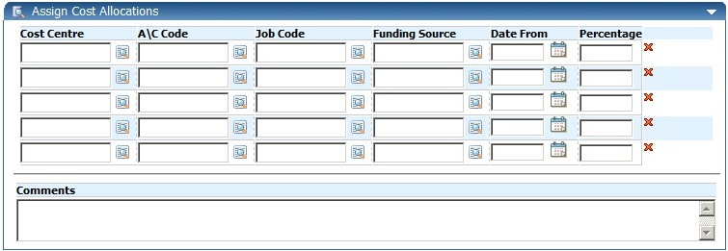

Account Code guidance can be accessed via the Financial Policies and Guidance wiki:
https://www.wiki.ed.ac.uk/display/Finance/Financial+Policies+and+Guidance

A direct link to “CODING STAFF COSTS – ACCOUNT CODES” guidance is:
https://www.wiki.ed.ac.uk/pages/viewpage.action?title=Financial+Policies+and+Guidance&spaceKey=Finance&preview=/55315483/286329101/Staff%20Costs%20account%20guidance%20160915.pdf

To select a cost centre (as with the Cost Centre field in the first part of the Staff Request) click on the magnifying glass icon and then type the cost centre (or letters/numbers contained in the cost centre) in the Search box. You will need to enter at least 2 numbers/letters in order for appropriate items to display. Next, click on the small magnifying glass to the right of the Search box and a list of cost centres containing the numbers/letters you entered will display. Select the correct cost centre.

You will need to do the same to complete the A\C Code, Job Code (once you have clicked on the magnifying glass icon you will need to wait for the box to display Select Job Code (at the top) before typing anything in the Search box), and Funding Source fields.

Funding Source is the funding source/body that the employee’s salary will be charged to.
The following rules should be applied when completing this field:
- Job Code = Snnnnn (i.e. S00001) then always use funding code UNIVERSITY OF EDINBURGH
- Job Code = Bnnnnn (i.e. B00001) then always use funding code DEPARTMENTAL INCOME
- Job Code = Gnnnnn (i.e G00001) then always use funding code DEPARTMENTAL FUNDS
- Job Code = Dnnnnn then always use funding code DEPARTMENTAL DONATIONS
- Job Code = Ennnnn then always use funding code ENDOWMENT
- For all other Job Codes (beginning R etc) please select the funding source/body from the pick list.

In the Date From field, enter today’s date (the date on which you are raising the Staff Request). Again, dates should be entered in the format DD/MM/YY. Alternatively, you can click on the calendar icon and then select the correct date.

It is possible to split the salary cost allocations but you will need to ensure that figures entered in the Percentage column add up to 100.

How to attach a document to a Staff Request
The Staff Request Documents section can be used to upload any appropriate documents. Approvers and HR will be able to view these documents when they approve/authorise the vacancy.

To attach a document, click on the blue paperclip icon within the Staff Request Documents box.

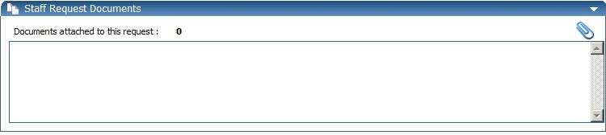

A separate window will open.

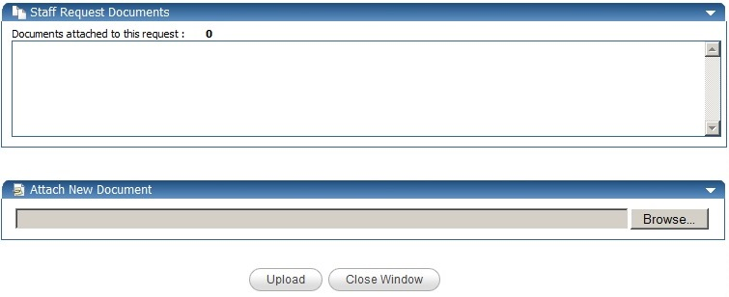
Click Browse, find and select your document and then click Open.

Click Upload and details of your document will appear in the Staff Request Documents section of the screen once the upload has taken place.
To view your document, click on the icon

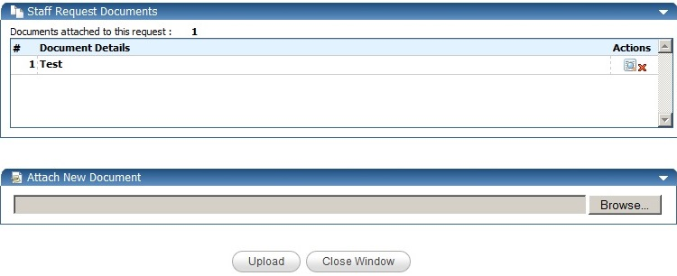
To delete your document, click on the icon

To continue with the rest of the Staff request, click on the Close Window button

How to complete fields within Advertising Details section

If your vacancy is not to be advertised at all, you do not need to do anything within the Advertising Details section.

Internal Vacancies - Advertising Details

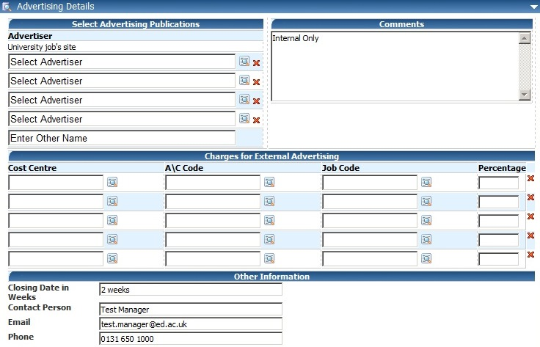

If the vacancy is for Internal applicants, type Internal Only in the comments box

The University’s Jobs site
www.vacancies.ed.ac.uk is chosen automatically by default.

Complete the Other Information section
This information will feed directly to the Vacancy and will show on the University’s Jobs site.

Enter the number of weeks that you require the vacancy to be advertised
(e.g. 2, 3 or 4 weeks).

Enter the full name of the contact person for the vacancy, their email address and their full phone number
(not just extension number).

NB: Details of the Contact Person may be passed to applicants.

External Vacancies - Advertising Details

If the vacancy is for External and Internal applicants

The University’s Jobs site www.vacancies.ed.ac.uk is chosen automatically by default.

A vacancy can be advertised by an external source.
Choose from a list by clicking on the icon. You can choose more than one external source.

If you cannot find the external source on
the list, then type the name in this field

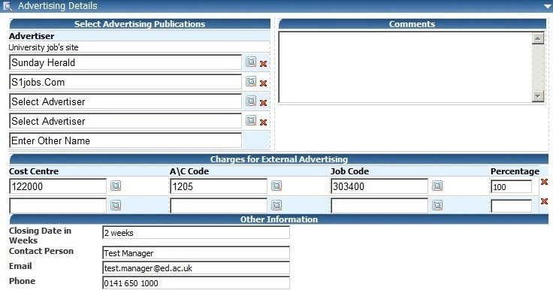
To remove an advertiser, click on the
icon

Advertising Details - Charges for External Advertising

Click on the icon to search for the correct Cost Centre, A\C Code and Job Code details.

The system will ensure that figures within the Percentage column add up to 100 in order to save and submit the Staff Request.

To remove a line of charge detail, click on the red X to the right of the row you wish to remove.

Complete the Other Information section
This information will feed directly to the Vacancy and will show on the University’s Jobs site.

Enter the number of weeks that you require the vacancy to be advertised (e.g. 2, 3 or 4 weeks).

Enter the full name of the contact person for the vacancy, their email address and their full phone number (not just extension number).

NB: Details of the Contact Person may be passed to applicants.

How to submit a completed Staff Request

When you have entered all the details for the request, you can either save the staff request and return to this in the future. Alternatively, you can save your staff request and submit this at the same time.
If you click on the Save button, then click the OK button on the confirmation message

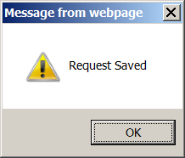

Then you are returned to the top of the page.
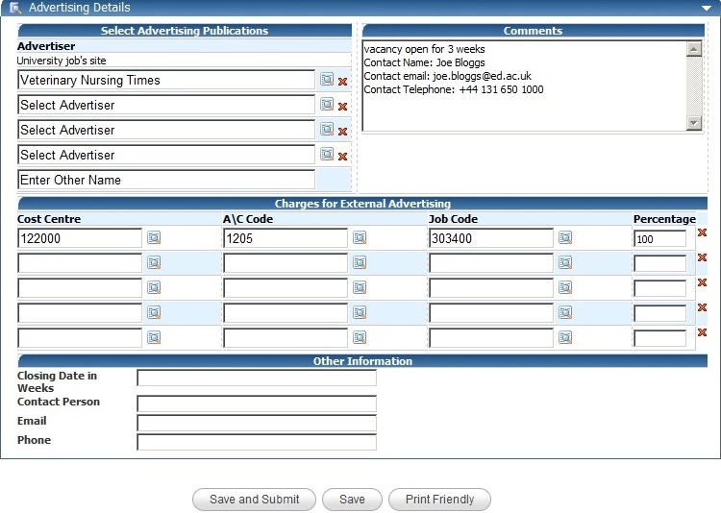
Your staff request is then held in your Planned requests until it is submitted.

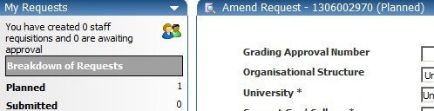
If you click on the Save and Submit button, then click the OK button on the confirmation message

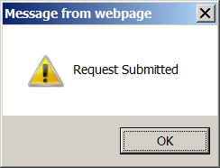

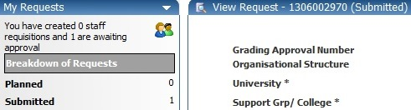
Your staff request is now sent to the approver and will move from your planned requests to your Submitted requests.

How to access a Staff Request once it has been saved or submitted

Log in to MyEd www.myed.ed.ac.uk and open the eRecruitment channel.

Click on the Launch eRecruitment button.

Click on the Staff Requests button.

The default screen will be My Requests: Planned
If you have any staff requests that have been started and not yet submitted, then they will show in this screen
If for any reason these do not display automatically, click on Planned
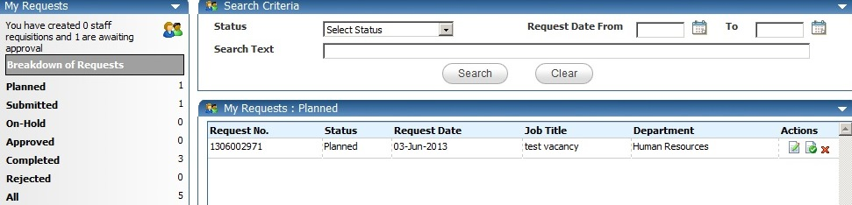
To delete a Staff Request which is partially completed or yet to be submitted, then click the icon.
To view / edit your staff request, click the icon.
The Staff Request will then open and you will be able to view/ edit as required.

Click OK and then OK again.

How to view a submitted but not yet approved Staff Request

Once a Staff Request has been submitted, a system generated email is sent to the 1st Approver advising a staff request requires their approval.

Once the 1st Approver has approved the Staff Request, a system generated email is sent to the 2nd Approver, advising a staff request requires their approval.

After a Staff Request has been approved by both Approvers, the Originator will receive a system generated email advising the request is approved and Local HR will contact the Originator with a Vacancy ID number. Similarly, if an Approver rejects the Request, the Originator will receive a system generated email advising request has been denied.

It is possible to view but not edit a submitted Staff Request. If you want to edit a Staff Request, it would be best to make a copy of the request. Edit the copied request and then submit.

Log in to MyEd www.myed.ed.ac.uk and open the eRecruitment channel.

Click on the Launch eRecruitment button.

Click on the Staff Requests button.

Click on Submitted

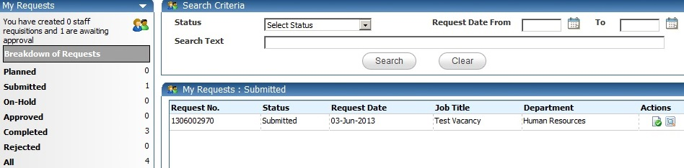

Click on the icon

Scroll to the bottom of the request where you will find the Approval History section.
Within this section, the Originator can view comments and check where the Staff Request is in the approval process.

You can see in this example, the 1st Level Approver has not yet approved.

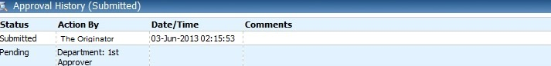

In this example, the 1st Level and 2nd Level approval has been completed.

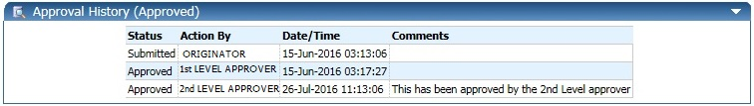

How to verify if a Staff Request has been converted to a Vacancy

After a Staff Request has been approved by both the 1st and 2nd level approvers, the Originator will receive a system generated email to advise the staff request has been approved.

The HR Systems will then create the Vacancy Reference number. After the Vacancy Reference number has been created, a system generated email is sent to Local HR, advising the Vacancy has been created. The Local HR team will scrutinise the request and then advise the Originator of the Vacancy Reference number.
This may take 2-3 working days.

The Originator can also view the progress to see if the Staff Request has been converted to a vacancy.

Log in to MyEd www.myed.ed.ac.uk and open the eRecruitment channel.

Click on the Launch eRecruitment button.

Click on the Staff Requests button.

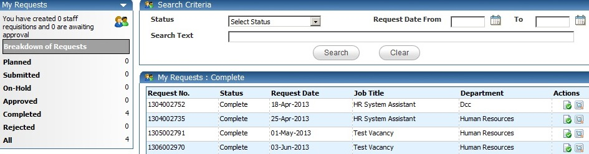

Click on Completed Then click on the icon.

The Staff Request will open.

Scroll to the bottom of the Staff Request and you can view the Approval History.

If the Approval History is showing Complete, it means the staff request has been approved and the Vacancy ID has been created.

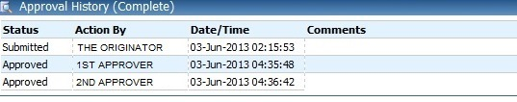

If your Staff Request is sitting in the My Requests: Approved, this would indicate the Staff Request has been approved, but the Vacancy ID has not been created.

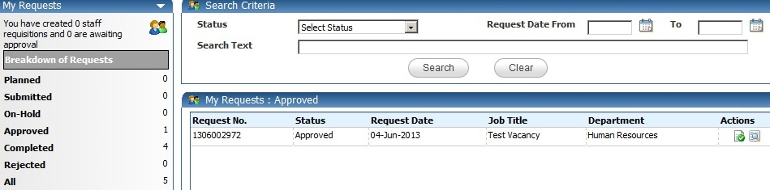

How to view when and why a Staff Request has been rejected

If a Staff Request is rejected, the Originator will be sent a system generated email advising the Staff Request has not been approved.

To view the rejected Staff Request:

Log in to MyEd www.myed.ed.ac.uk and open the eRecruitment channel.

Click on the Launch eRecruitment button.

Click on the Staff Requests button.

Click on My Requests: Rejected to view the rejected vacancy.

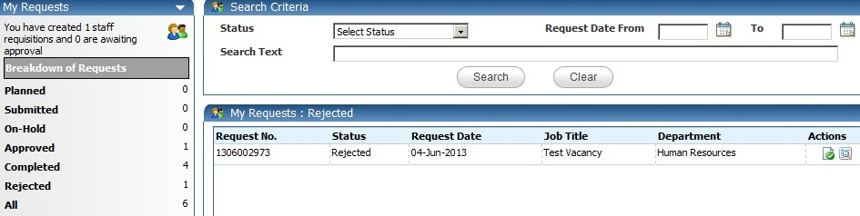

Then click on the icon.

The rejected staff request will open.

Scroll to the bottom to see which approver rejected the request and what the reason was.

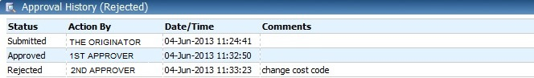

The status shows rejected
Which Approver rejected
Why it was rejected

If an Approver has rejected a Staff Request and has provided feedback on required amendments, the Originator can copy the rejected Staff Request, then amend the copied staff request and submit. The rejected staff request would just stay in the My Requests: Rejected section for historical purposes.

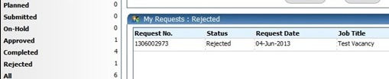

How to search for a specific Staff Request

You can use the Search Criteria box at the top of the screen to find a particular Staff Request or category of Staff Requests if you know which status they fall under.

Log in to MyEd www.myed.ed.ac.uk and open the eRecruitment channel.

Click on the Launch eRecruitment button.

Click on the Staff Requests button.

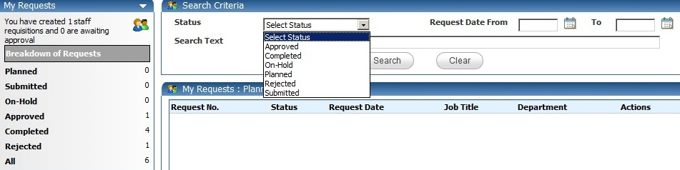
Select a status from the drop down list

You must always select a status in order to use the Search Criteria facility.

After the status is selected, you can search by keyword. If you know the Staff Request number, type this in the Search Text box.
As well as using keyword search, you can search by using a date range.
Type the date in dd/mm/yy format, or click the icon to pick from the calendar.

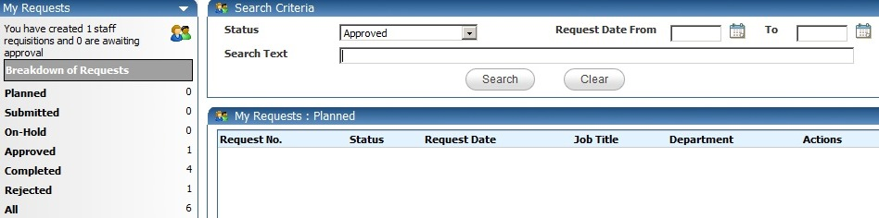

Once you have entered your search criteria, click Search.

Alternatively, click on All.

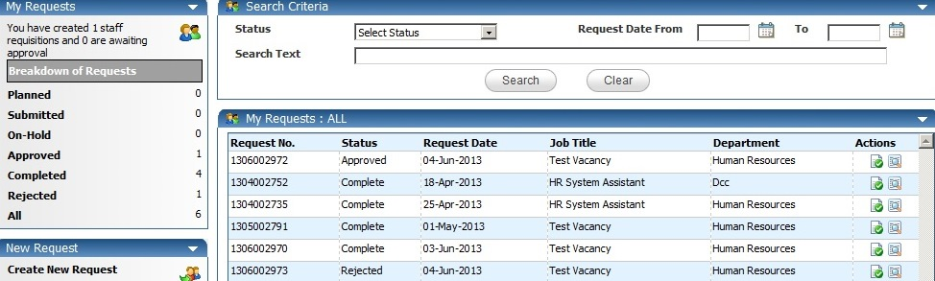

This will list all of your Staff Requests regardless of their status.
You can scroll up and down to find your vacancy and the click the icon to view the request.

How to print a Staff Request

Log in to MyEd www.myed.ed.ac.uk and open the eRecruitment channel.

Click on the Launch eRecruitment button.

Click on the Staff Requests button.

Open your staff request by clicking on the icon.

Scroll to the bottom of the staff request.

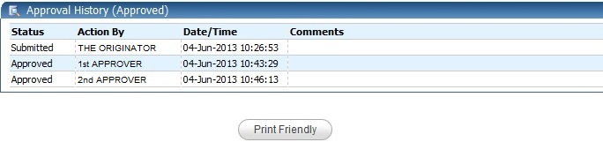
Click the Print Friendly button

A new window will open showing the Staff Request.
Scroll to the bottom of the opened window.

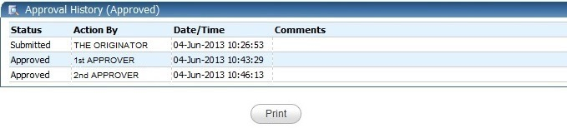
Click the Print button

This will open the print window to allow you to choose which printer you want to print to.

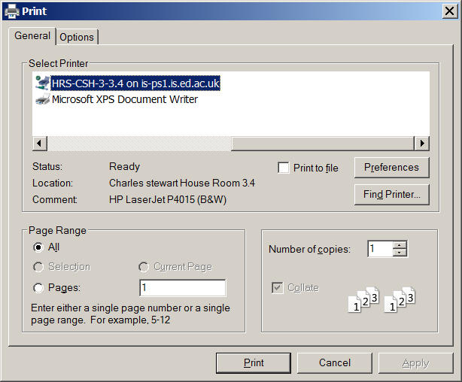

How to copy a Staff Request

A Staff Request can be copied from an existing Staff Request by the same Originator.

It’s not possible to copy a staff request from a fellow Originator.

Additionally, if an Approver has rejected a Staff Request, and has provided feedback on amendments that need to be made, the Originator can copy the rejected Staff Request and submit the amended copy

Log in to MyEd www.myed.ed.ac.uk and open the eRecruitment channel.

Click on the Launch eRecruitment button.

Click on the Staff Requests button.

In this instance, we are looking at a rejected staff request in the My Requests: Rejected section

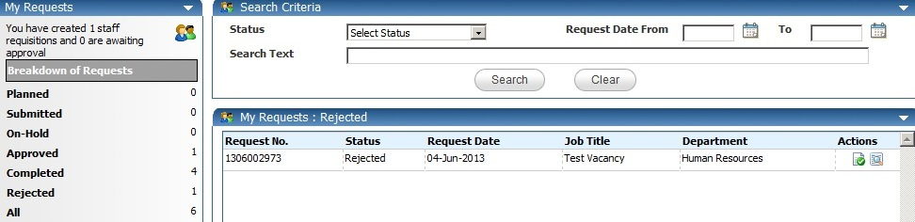

Copy the staff request by clicking on the icon.
A confirmation message will appear.

Click OK.
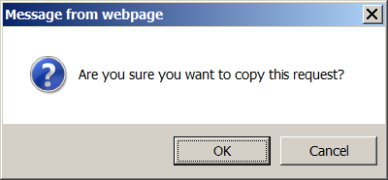

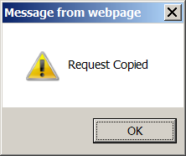
The action is complete.

Click OK.

Wait for 10 – 15 seconds until the new staff request which has all the same details as the rejected staff request is generated and loaded on your screen.

The new staff request will show as Amend Request and have a new staff request number.

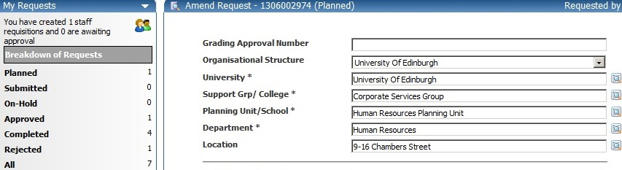

The new staff request will be held in your My Requests: Planned section.
NB: Please scroll to bottom of screen and save your changes.

How to exit eRecruitment

From the Core Portal screen.

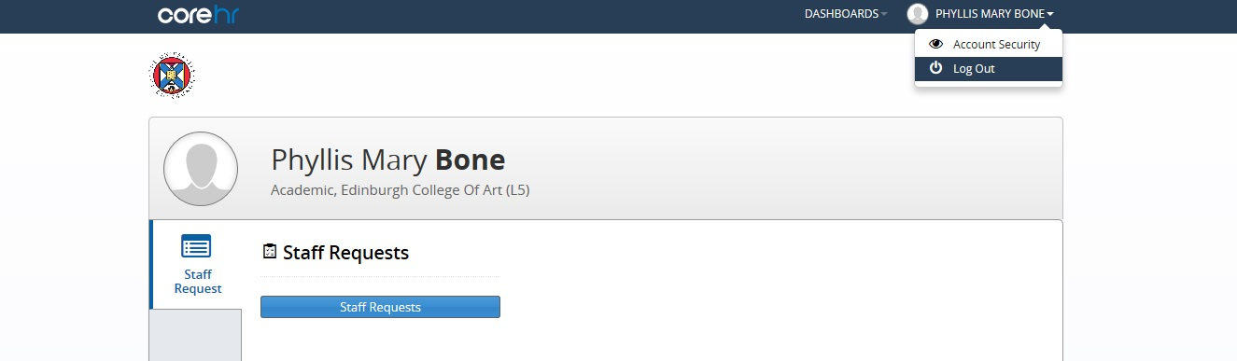

Click on your name in the top right corner, then click on Log Out.

