How to submit a completed Staff Request

When you have entered all the details for the request, you can either save the staff request and return to this in the future. Alternatively, you can save your staff request and submit this at the same time.
If you click on the Save button, then click the OK button on the confirmation message

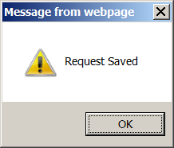

Then you are returned to the top of the page.
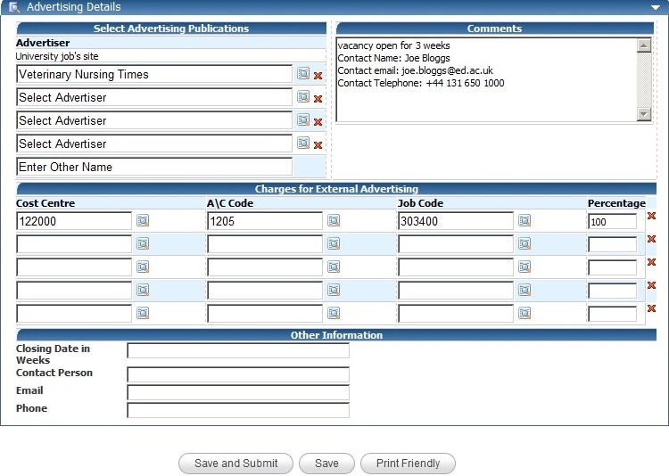
Your staff request is then held in your Planned requests until it is submitted.

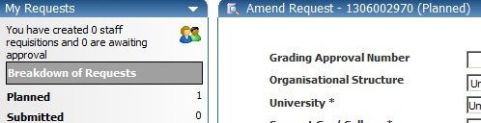
If you click on the Save and Submit button, then click the OK button on the confirmation message

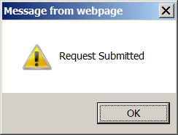

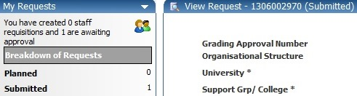
Your staff request is now sent to the approver and will move from your planned requests to your Submitted requests.

