How to exit eRecruitment

From the Core Portal screen.

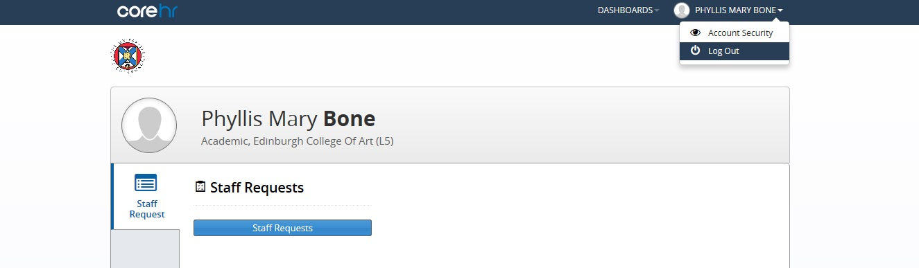

Click on your name in the top right corner, then click on Log Out.

