How to attach a document to a Staff Request

The Staff Request Documents section can be used to upload any appropriate documents. Approvers and HR will be able to view these documents when they approve/authorise the vacancy.

To attach a document, click on the blue paperclip icon within the Staff Request Documents box.

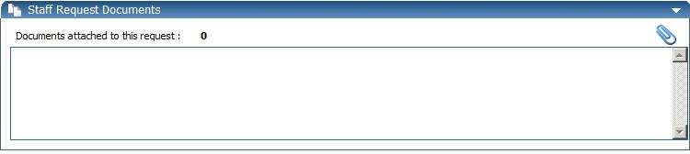

A separate window will open.

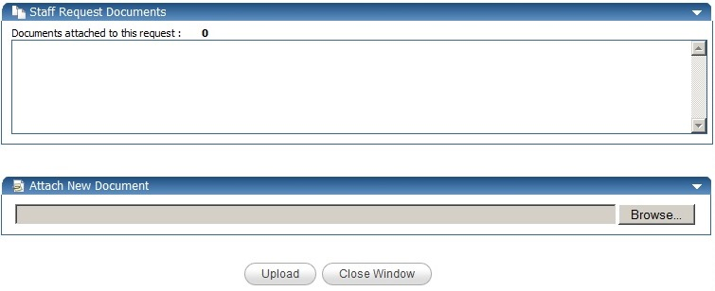
Click Browse, find and select your document and then click Open.

Click Upload and details of your document will appear in the Staff Request Documents section of the screen once the upload has taken place.
To view your document, click on the icon

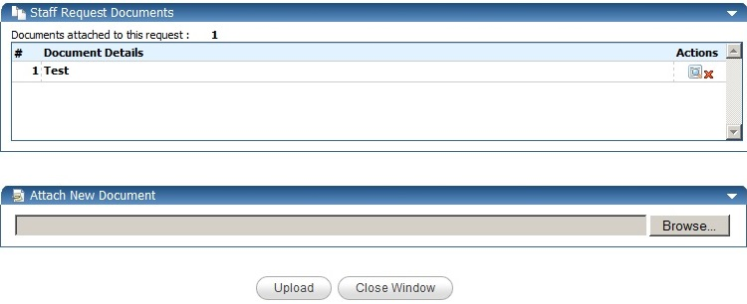
To delete your document, click on the icon

To continue with the rest of the Staff request, click on the Close Window button

