How to view a submitted but not yet approved Staff Request

Once a Staff Request has been submitted, a system generated email is sent to the 1st Approver advising a staff request requires their approval.

Once the 1st Approver has approved the Staff Request, a system generated email is sent to the 2nd Approver, advising a staff request requires their approval.

After a Staff Request has been approved by both Approvers, the Originator will receive a system generated email advising the request is approved and Local HR will contact the Originator with a Vacancy ID number. Similarly, if an Approver rejects the Request, the Originator will receive a system generated email advising request has been denied.

It is possible to view but not edit a submitted Staff Request. If you want to edit a Staff Request, it would be best to make a copy of the request. Edit the copied request and then submit.

Log in to MyEd www.myed.ed.ac.uk and open the eRecruitment channel.

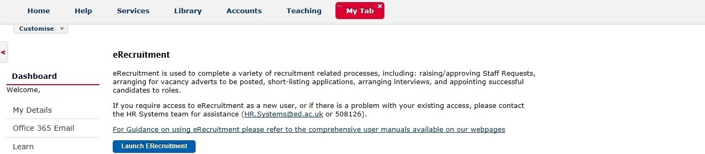

Click on the Launch eRecruitment button.

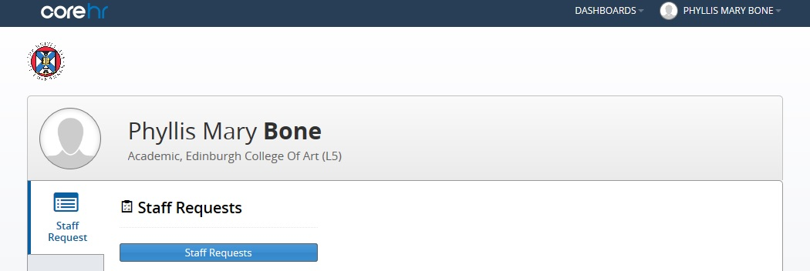

Click on the Staff Requests button.

Click on Submitted

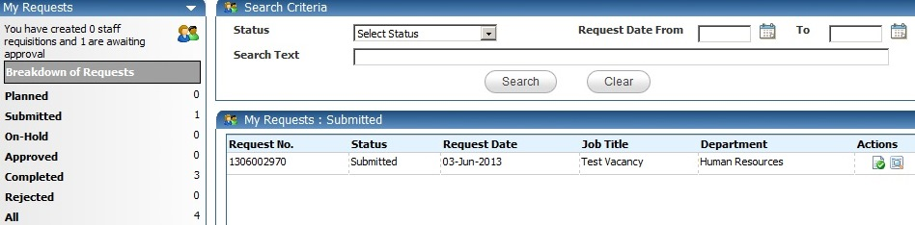

Click on the icon

Scroll to the bottom of the request where you will find the Approval History section.
Within this section, the Originator can view comments and check where the Staff Request is in the approval process.

You can see in this example, the 1st Level Approver has not yet approved.

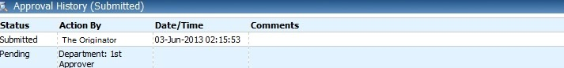

In this example, the 1st Level and 2nd Level approval has been completed.

