How to view when and why a Staff Request has been rejected

If a Staff Request is rejected, the Originator will be sent a system generated email advising the Staff Request has not been approved.

To view the rejected Staff Request:

Log in to MyEd www.myed.ed.ac.uk and open the eRecruitment channel.

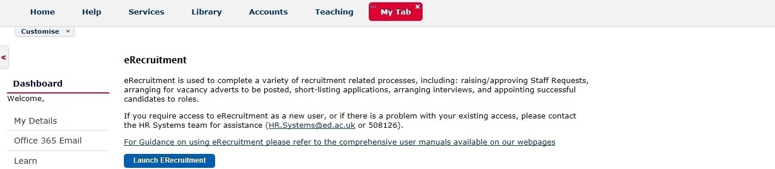

Click on the Launch eRecruitment button.

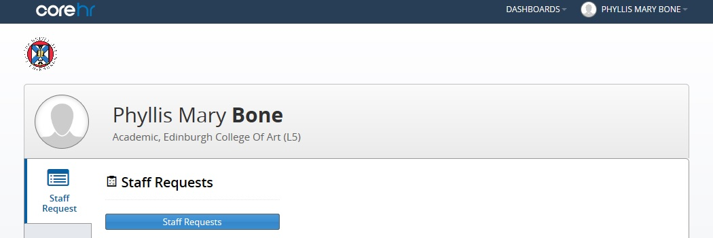

Click on the Staff Requests button.

Click on My Requests: Rejected to view the rejected vacancy.

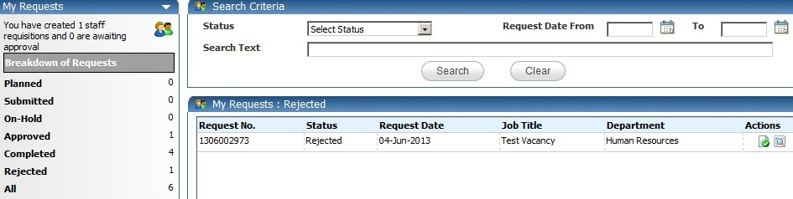

Then click on the icon.

The rejected staff request will open.

Scroll to the bottom to see which approver rejected the request and what the reason was.

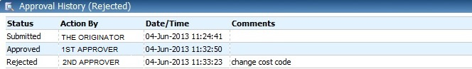

The status shows rejected
Which Approver rejected
Why it was rejected

If an Approver has rejected a Staff Request and has provided feedback on required amendments, the Originator can copy the rejected Staff Request, then amend the copied staff request and submit. The rejected staff request would just stay in the My Requests: Rejected section for historical purposes.

