How to print a Staff Request

Log in to MyEd www.myed.ed.ac.uk and open the eRecruitment channel.

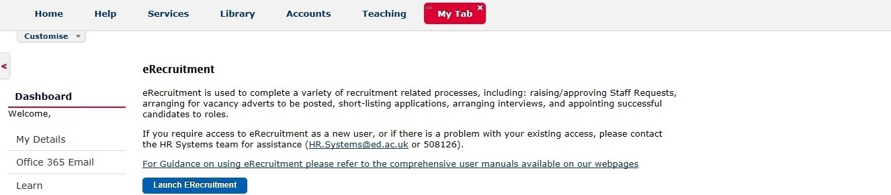

Click on the Launch eRecruitment button.

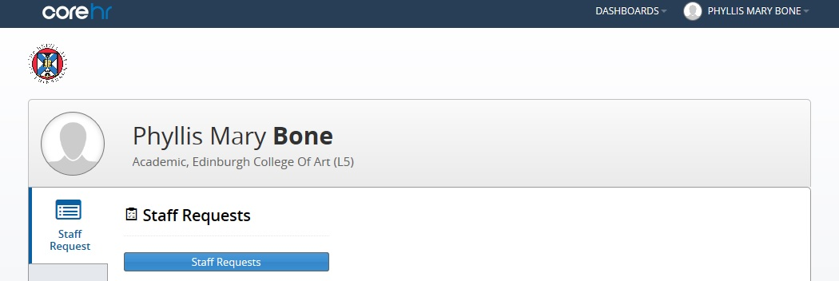

Click on the Staff Requests button.

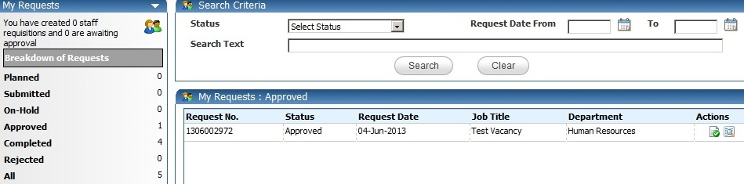

Open your staff request by clicking on the icon.

Scroll to the bottom of the staff request.

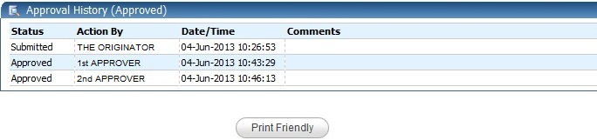
Click the Print Friendly button

A new window will open showing the Staff Request.
Scroll to the bottom of the opened window.

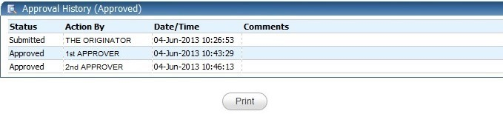
Click the Print button

This will open the print window to allow you to choose which printer you want to print to.

