How to access the eRecruitment system

Log in to MyEd www.myed.ed.ac.uk and open the eRecruitment channel.

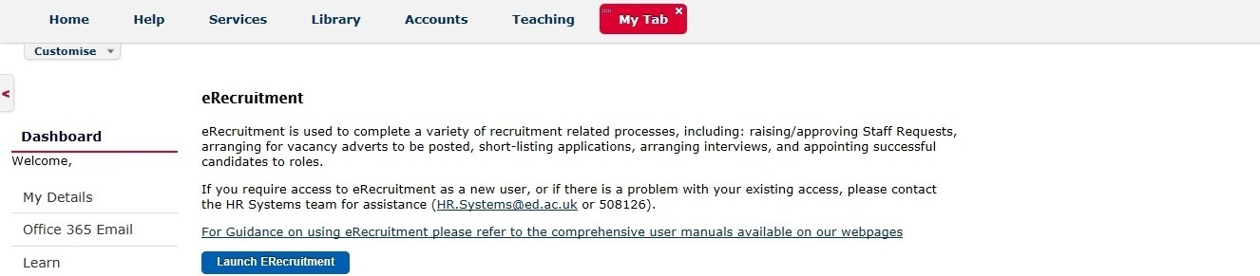

Click on the Launch eRecruitment button.

If you are unable to locate eRecruitment in MyEd, you can add the eRecruitment channel.

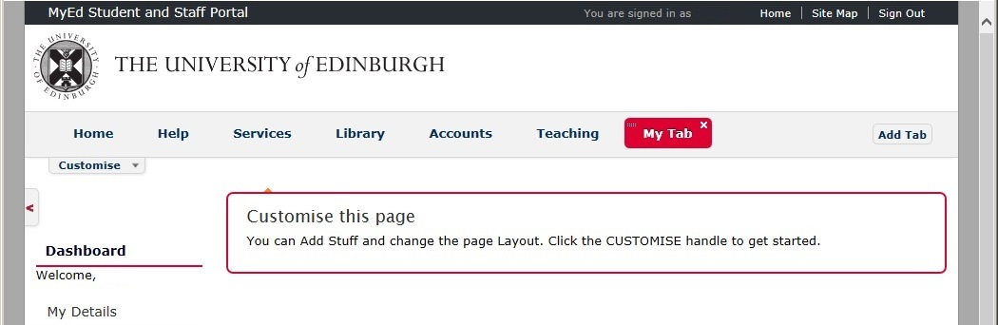

- Click on a Tab
- “My Tab” has been clicked on.
(NB: To indicate it has been clicked on,
the tab background colour is red.)
- Click on Customise

A drop down panel will open, which will allow you to “Add Stuff”

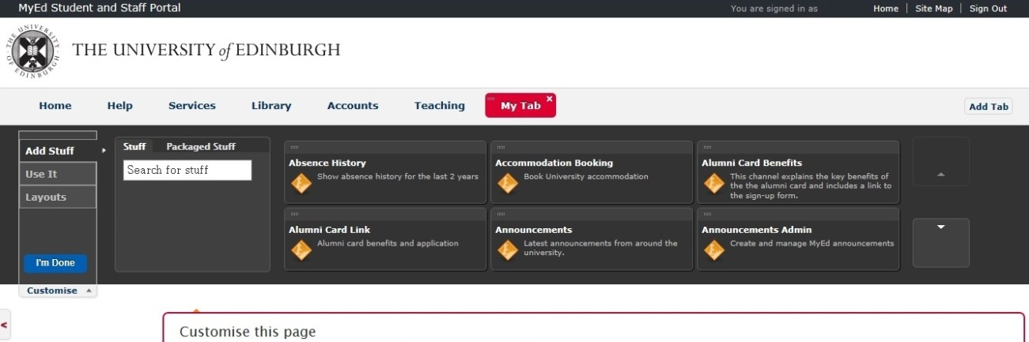
Click the Scroll down arrow until you find the “eRecruitment” channel.

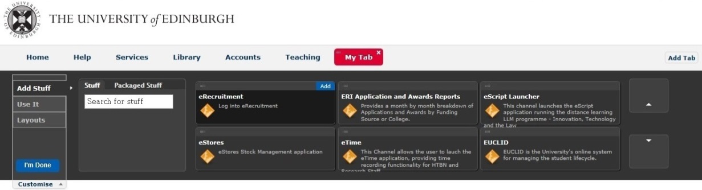
Hover your mouse over the “eRecruitment” channel and then click on Add

This will add the “eRecruitment” channel into your “My Tab” space.

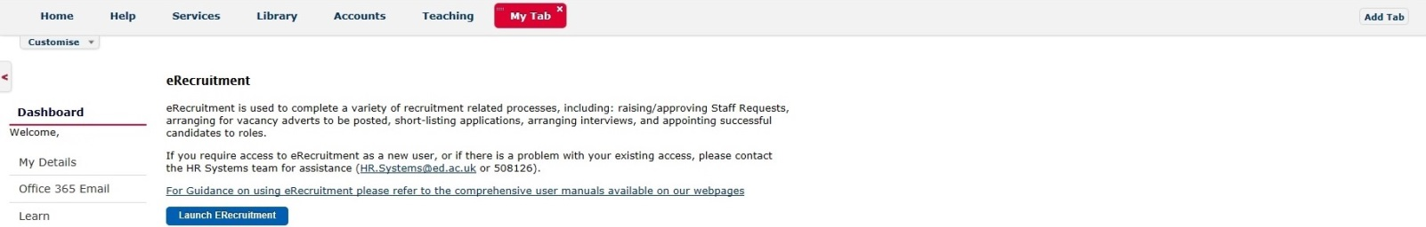

This is available in video tutorial, called “Customising your layout” and can be viewed at:
http://www.ed.ac.uk/schools-departments/information-services/computing/comms-and-collab/myed-portal/using-myed

When you click on the Launch ERecruitment button in MyEd, you will be directed to this screen:

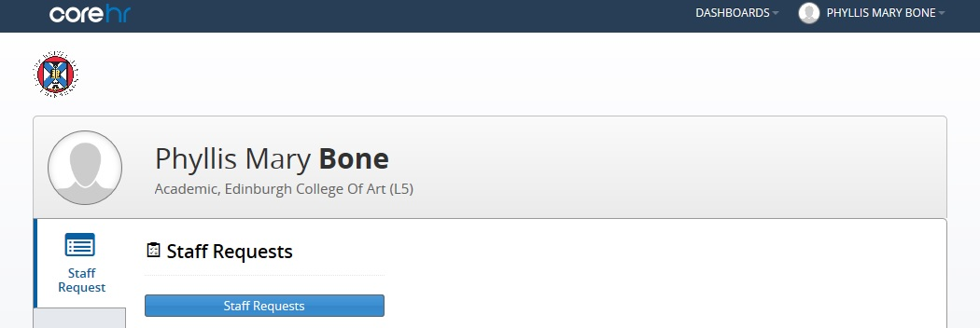

Click on the Staff Requests button.

