How to exit eRecruitment

Click on your name at the top right side of the screen.

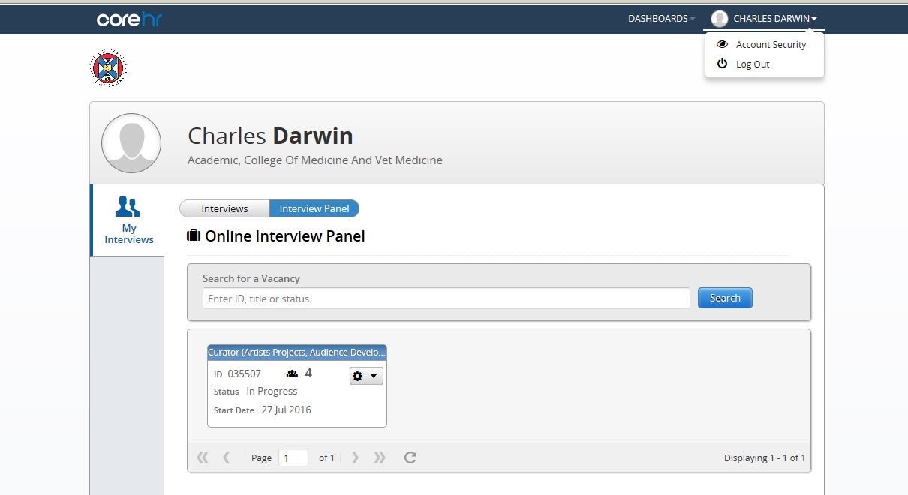

Click on Log Out

