eRecruitment

Interviewer User Manual
How to access the eRecruitment system 2
How to view Applicants and Applications 5
How to view details of interviews taking place within the next 5 days 8
How to exit eRecruitment 12

How to access the eRecruitment system
Log in to MyEd www.myed.ed.ac.uk and open the eRecruitment channel.

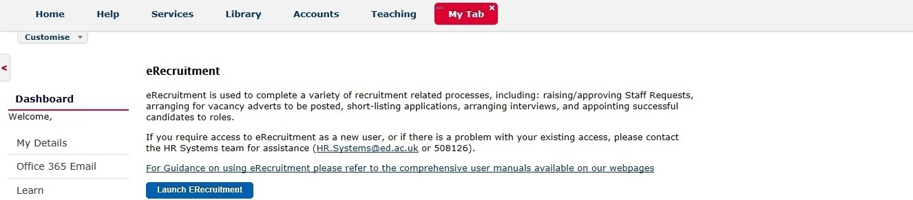

Click on the Launch eRecruitment button.

If you are unable to locate eRecruitment in myED, you can add the eRecruitment channel.

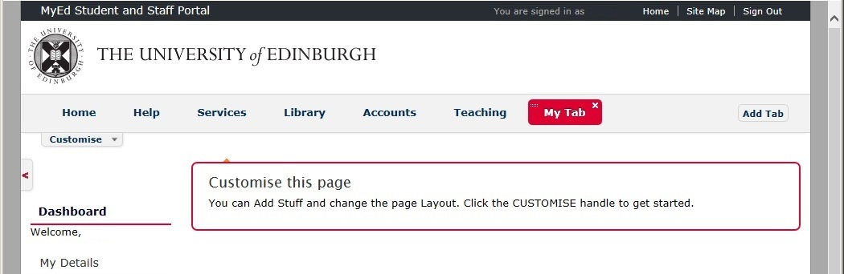

- Click on a Tab
- “My Tab” has been clicked on.
(NB: To indicate it has been clicked on,
the tab background colour is red.)
- Click on Customise

A drop down panel will open, which will allow you to “Add Stuff”

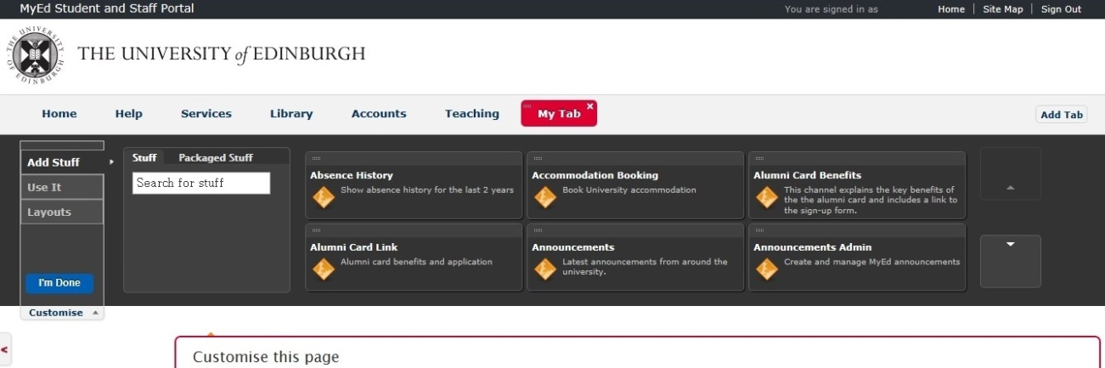
Click the Scroll down arrow until you find the “eRecruitment” channel.
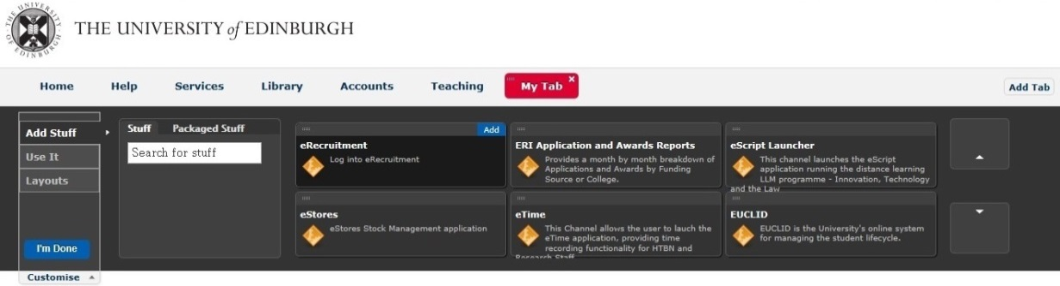
Hover your mouse over the “eRecruitment” channel and then click on Add

This will add the “eRecruitment” channel into your “My Tab” space.

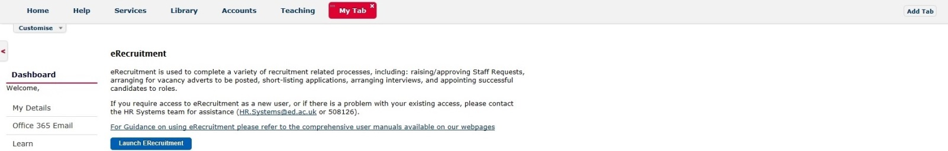

This is available in video tutorial, called “Customising your layout” and can be viewed at:
http://www.ed.ac.uk/schools-departments/information-services/computing/comms-and-collab/myed-portal/using-myed

When you click on the Launch ERecruitment button in MyEd, you will be directed to this screen:

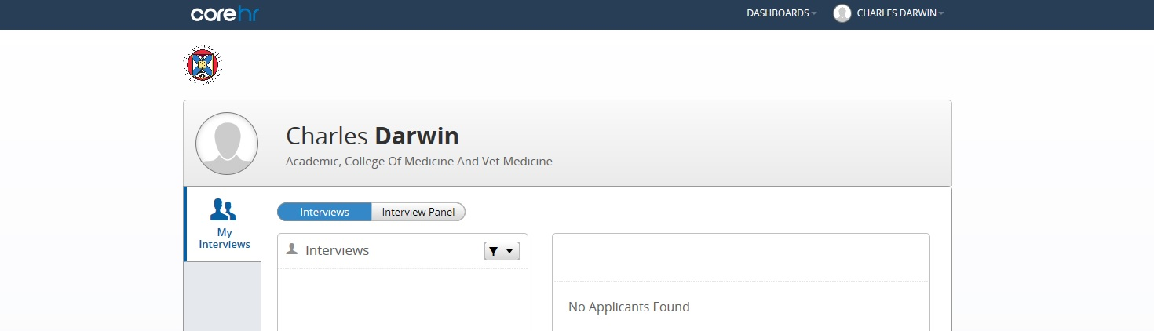

Click on Interview Panel button to view detail about your vacancy.

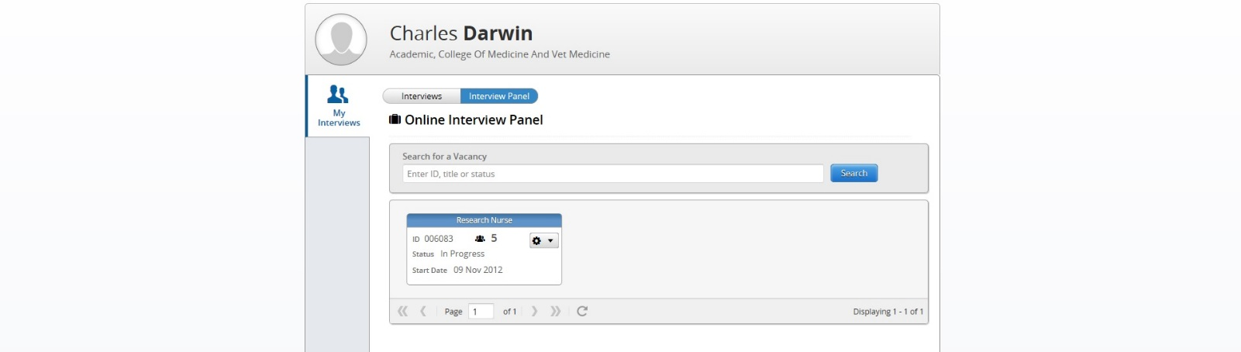

The Recruiter will add an interviewer to the interview panel, which will allow the interviewer to view vacancies.
If you are not able to see the vacancy in the Interview Panel screen, please contact the Recruiter and ask to be added to the Interview Panel for the specific vacancy.

If the Interviewer experiences the following screen, it is possible they have not been added to the Interview Panel.

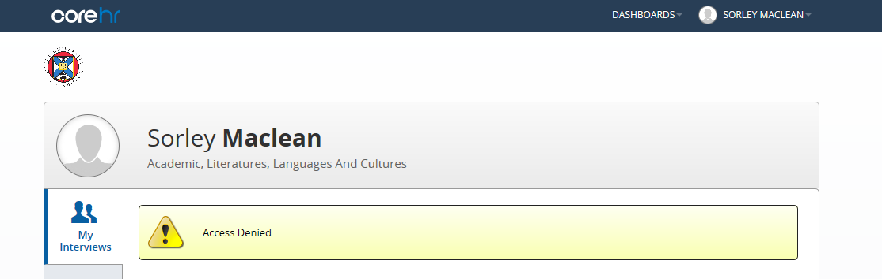

To remedy the above error, the Interviewer should make contact with the recruiter and ask to be added to the Interview Panel.

How to view Applicants and Applications

Click on the Launch eRecruitment button.
You will be directed to this screen:

Click on Interview Panel button to view detail about your vacancy.

If the Interviewer is on the Interview panel, the vacancy will populate on this page. It is possible to enter the vacancy number and click on Search if the Interviewer is linked to many vacancies.
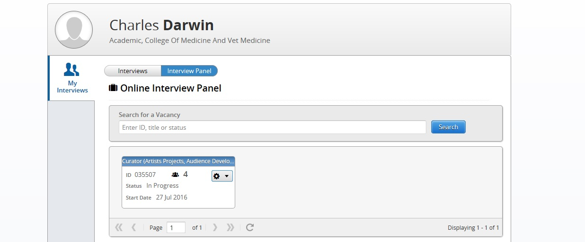
The Recruiter will add an interviewer to the interview panel, which will allow the interviewer to view vacancies.
If the Interviewer is not able to see the vacancy in the Interview Panel screen, please contact the Recruiter and ask to be added to the Interview Panel for the specific vacancy.

The Interviewer can view the listing of applicants and view their individual applications.

Click on the cog wheel icon.

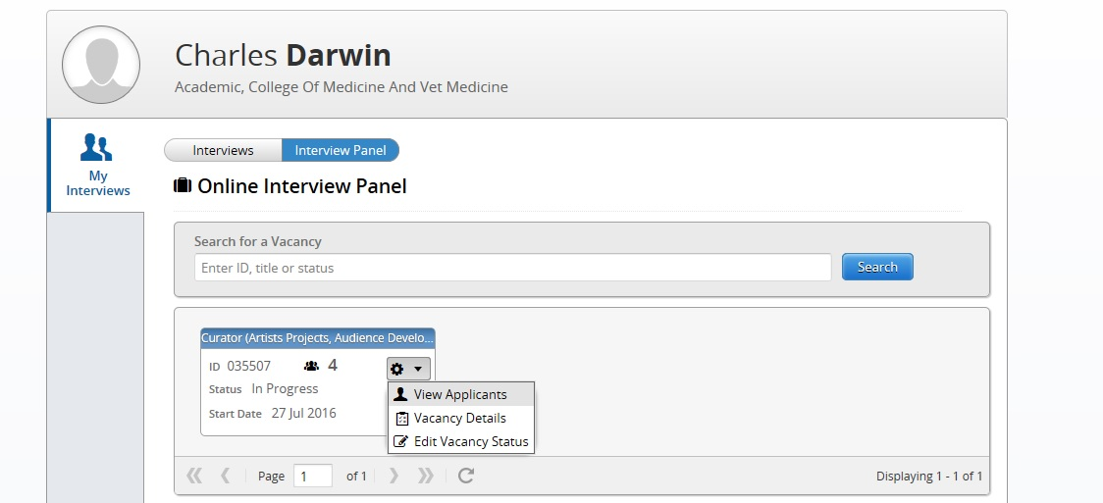

Click on View Applicants.
It is possible for the Interviewer to click on the “Vacancy Details” and “Edit Vacancy Status” options. However, for Interviewers these options are not active. Recruiters are able to update the necessary sections on behalf of the Interviewer in the back office.

After clicking View Applicants, the following screen will appear listing the applicants and their applicant status.
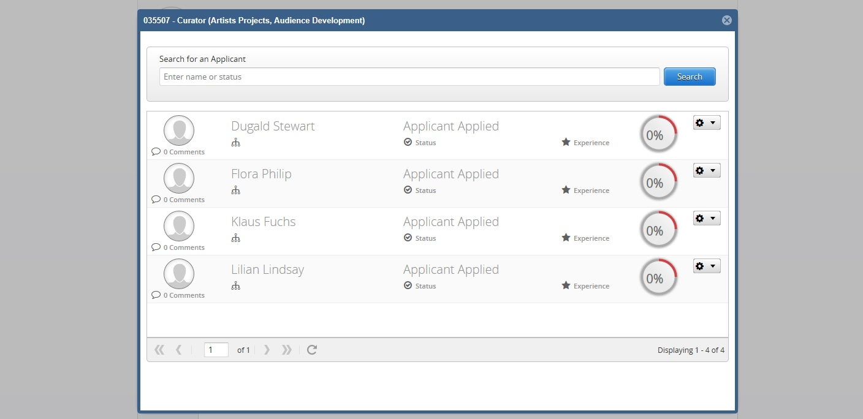

To view individual applications, click on the cog wheel icon.

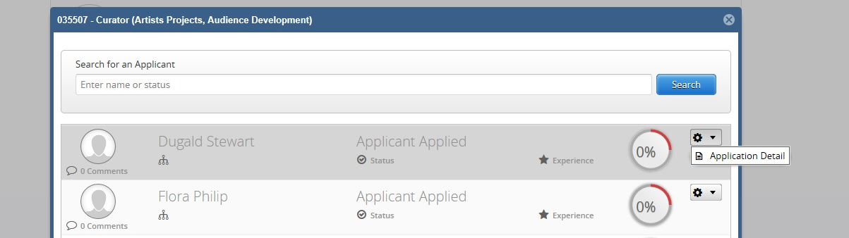

Then click on Application Detail.

This will open the application in a web browser window.

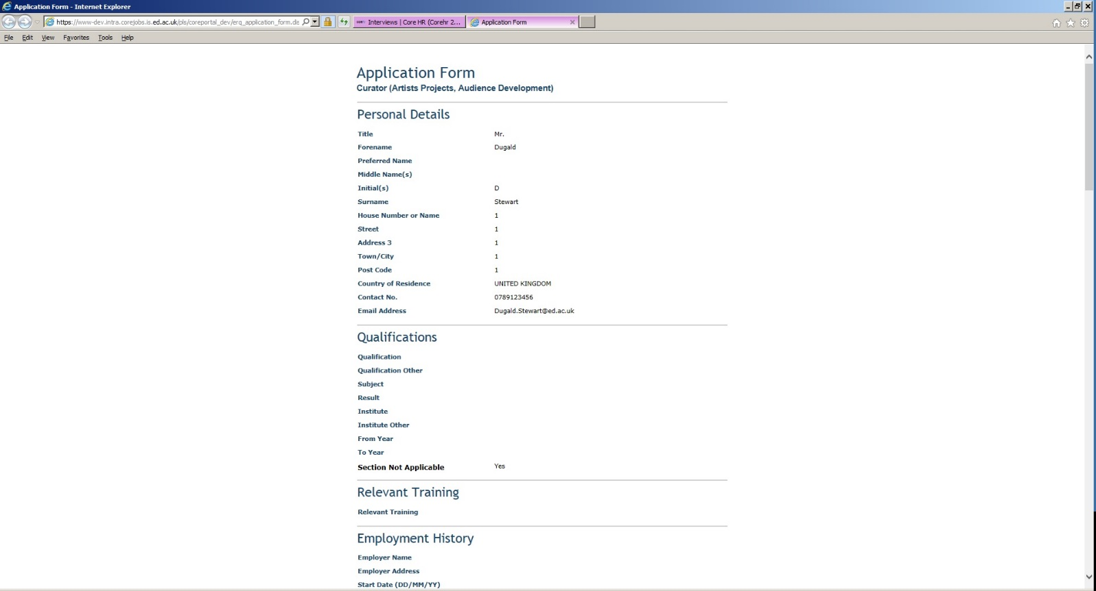

How to view details of interviews taking place within the next 5 days

The Interviewer can check what Interviews are taking place in the next 5 days.
The interviewer can log into eRecruitment by doing the following.

Click on the Launch eRecruitment button.

The first screen the interviewer will see is:
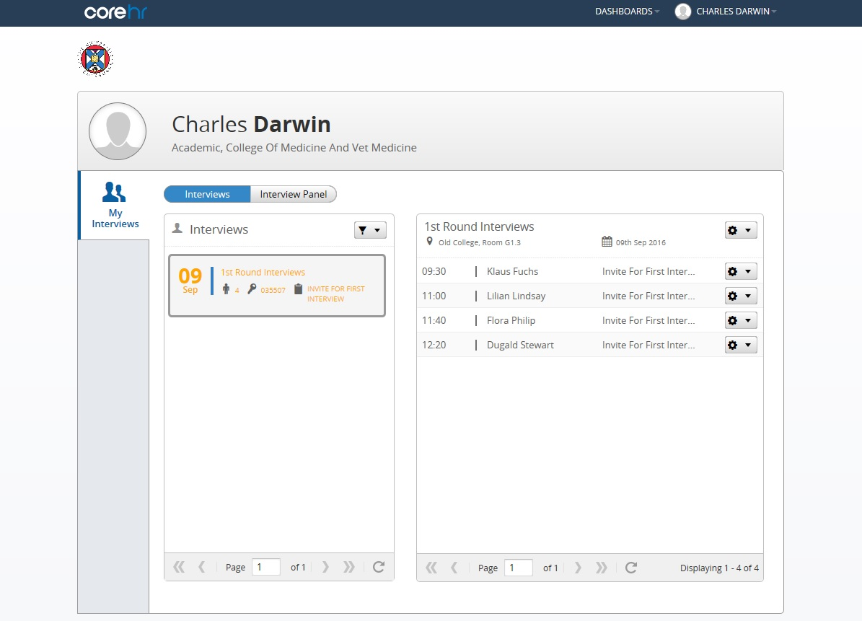

If the interviewer has an upcoming interview within the next 5 days, and the recruiter has created an interview schedule and assigned the interviewer to the interview schedule, then this will appear for the interviewer as soon as they log in.

If the interviewer is not able to see a vacancy as soon as they log into the screen, this could be for any of the following reasons:

- The recruiter has not added the interviewer to the interview panel.

- The recruiter has added the interviewer to the interview panel, but not created an interview schedule and assigned both the interviewers and applicants to the interview schedule.

- The recruiter has added the interviewer to the interview panel, AND has created the interview schedule and assigned both the interviewers and applicants to the interview schedule, but the date of the interview on the schedule is not within 5 days of the date the interviewer has logged into Core Portal.

On the Interviews screen, the interviewer can glean the following detail:

Date of Interviews

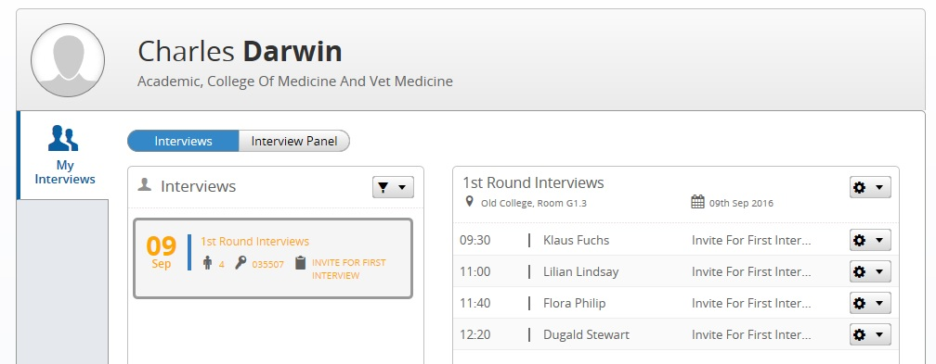

Vacancy Number Location of Interviews Applicant Names and corresponding interview time

For scenario c) the interviewer can check if they are assigned to the interview schedule by selecting All in the filter.
This will list all the Interview Schedules the Interviewer has been assigned to regardless of date.
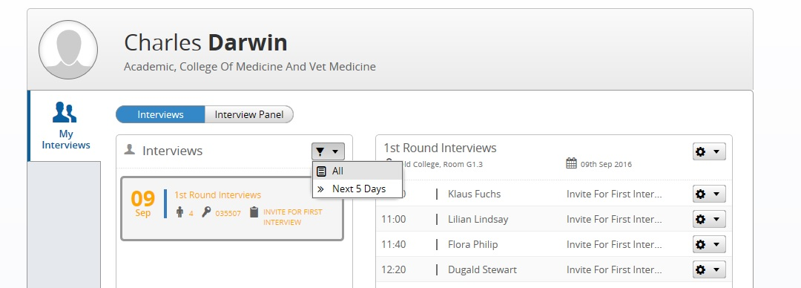

For scenario b) the interviewer can view applications, but unable to view details of the actual interview until the schedule has been created and assigned to interviewers and applicants.
To view applications the interviewer can click on Interview Panel button

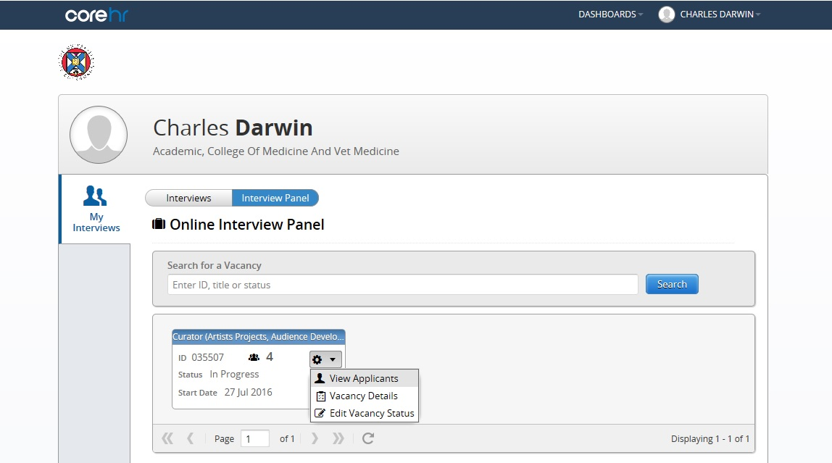

Then click on the cog wheel icon, then click on View Applicants.

After clicking View Applicants, the following screen will appear listing the applicants and their applicant status.

To view individual applications, click on the cog wheel icon.

Then click on Application Detail.

This will open the application in a web browser window.

How to exit eRecruitment
Click on your name at the top right side of the screen.

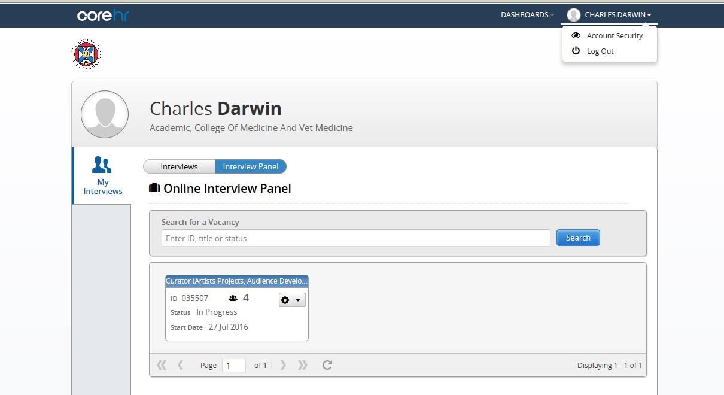

Click on Log Out

